Exploring volatile organic compound emission from thermally modified wood by PTR-ToF-MS

Authors

Andrea Romano¹, Luca Cappellin¹, Ignazia Cuccui², Sara Bogialli¹, Iuliia Khomenko³, Matteo Tonezzer⁴, Franco Biasioli³, Paolo Pastore¹, Ottaviano Allegretti^{2*}

Affiliation:
¹ Department of Chemistry, University of Padova, Via Marzolo, 1 – 35131 Padova – Italy
² CNR-IBE Istituto per la Bioeconomia of the National Research Council of Italy, via Biasi, 75 – 38010 San Michele all'Adige – TN, Italy
³ Research and Innovation Centre, Edmund Mach Foundation, Via Edmund Mach, 1 - 38010 San Michele all'Adige – TN, Italy
⁴ CNR-IMEM, via della Cascata, POVO – TN, Italy

*Corresponding author:
ottaviano.allegretti@ibe.cnr.it
CNR-IBE, via Biasi, 75 – 38010 San Michele all'Adige – TN, Italy

Keywords: Volatile organic compounds; wood; thermal treatment; PTR-ToF-MS.

Abstract

Thermal modification of wood is a well-known industrial process performed to increase durability and dimensional stability or to change the colour of the natural wood. The treatment influences many other properties of wood including the emission of volatile organic compounds (VOCs). VOC release ultimately affects the quality of indoor air and the capability to have low VOC emission is often included as a key parameter for the attribution of quality labels.
In the present work, wood from six tree species was submitted to different types of treatment and VOC profiling was carried out on both treated and untreated samples by means of PTR-ToF-MS. This work represents the first example of application of PTR-ToF-MS to the analysis of VOCs emitted by thermally treated wood. It was possible to determine the main classes of wood VOCs without the need for sample pre-treatment and the rapidity of the analysis allowed to inspect the effect of many different variables, such as tree species, tissue type, treatment conditions and the combination thereof. Hardwood and softwood showed different release profiles under all tested conditions and compounds with similar chemical structures reacted in similar ways to treatment. With its high sensitivity and throughput, PTR-ToF-MS appears to be a very powerful analytical tool, useful in supporting the selection of wood materials for different end uses.
Introduction

Like most materials, wood releases volatile organic compounds (VOCs) that affect the quality and composition of indoor air, with possible consequences on human and animal health [1,2]. The US, as well as several European countries, are applying increasing restrictions to the VOC emissions of wood materials to be used in furniture and construction materials. The European Union publishes a list of target compounds associated to Lowest Concentration of Interest values (LCI values, https://ec.europa.eu/growth/sectors/construction/eu-lci-subgroup/eu-lci-values_it ): as of December 2021, this list contained nearly 200 individual entries, each corresponding to a compound of possible concern, based on a combination of toxicological and epidemiological data. National institutions within the EU have adopted analogous lists of compounds and concentrations which are then used to establish guidelines for the attribution of ‘EcoLabels’ [3]. Such certifications, even though not mandatory, can be adopted by producers on a voluntary basis and represent an added value in an increasingly environment- and health-conscious market.
VOCs released from wood belong to several different chemical classes. Terpenes and terpenoids are, in terms of relative abundance, the main constituent of the VOC profiles of wood issued from coniferous tree species, also commonly referred to as ‘softwood’, whereas in wood from deciduous trees (i.e. hardwood), terpenes are less abundant or non-detectable [4,5]. Aldehydes and ketones, carboxylic acids and esters, furans, phenols and aromatic and aliphatic hydrocarbons are other well-represented VOC classes in both hardwood and softwood [1,6].
Thermal modification of wood is carried out with the aim to modify some of its properties. Thermally modified wood is properly defined by the CEN / TS 15679: 2007 standard (Thermal Modified Timber - Definitions and characteristics) as "wood in which the composition and physical properties of the cell wall are modified permanently and throughout the thickness of the sawn timber by mean of exposure to temperatures above 160° C in conditions of reduced oxygen availability ".
The properties of thermally modified wood (TMW) and the extent of the modification depend on the wood species, the type of technology and the process parameters, especially on the maximum treatment temperature. Mass loss (ML) of the lumber because of heat treatment is the main indicator of the intensity of modification. Technologies for the production of TMW are mainly characterized by the way in which the concentration of oxygen is reduced during the treatment. The systems currently used on an industrial scale include superheated steam, nitrogen, vacuum, oil bath and are patented with different names [7].
TMW is a greener alternative to chemically treated wood. Compared to the unmodified material, TMW has improved characteristics in terms of dimensional stability, water sorption and resistance to microbial attack. TMW also has a darker colour throughout the thickness, which is appreciated by architects and designers and allows to substitute expensive tropical timber with local wood species. TMW is particularly amenable to non-structural end-uses such as indoor decking and cladding; however, the impact of thermal treatment on wood VOC emission must also be carefully taken into consideration. Literature data are mostly in agreement in showing that upon thermal treatment terpene and terpenoids decrease whereas the emission of most of the other VOC classes is promoted. This was observed for Scots pine [8,9], southern yellow pine [10] and Norway spruce and poplar [11]. A different result was reported by Hyttinen and colleagues [12], who found that heat treatment increased furfural but reduced hexanal emission in Norway spruce, Scots pine and European aspen.
Several official methods define methodologies for the measurements of VOCs emitted by construction and furniture materials. These entail the use of test chambers [13] or test cells [14]. Air and volatiles are swept into a thermal desorption (TD) tube, which is analysed by TD coupled to gas chromatography-mass spectrometry (GC-MS). The size of the chambers (typically 1-30 m³) and the need to sample manually limit the analytical throughput of this approach. Even though sampling using TD tubes is the most widespread technique for the study of wood emission, other sample prep protocols have been adopted in association with GC-MS, such as solid-liquid extraction [15], static and dynamic headspace [5,16], solid-phase micro extraction [17], accelerated solvent extraction [18] and direct remote sampling using passivated canisters, followed by TD-GC-MS [19]. All these approaches are limited in throughput because GC-MS analysis, and sometimes sample pre-treatment, are time consuming steps. Studies published so far have often been restricted to one to three different species, sometimes focusing on a single tree and wood type (i.e., either deciduous trees/hardwood or coniferous trees/softwood). Direct comparison between literature works, albeit possible, is made difficult by the fact that when different sample prep techniques are used, the respective ranges of sampled compounds will only be partially overlapping. Finally, it must be noted that most studies ignore potentially health-relevant VOCs emitted by wood such as methanol, acetaldehyde, formic acid and formaldehyde, because due to their chemical-physical characteristics, these are not retained -or poorly retained- by the Tenax-based sorbents used in the majority of TD tubes [20].
PTR-ToF-MS has previously been used to discriminate untreated wood core samples originating from 14 different tree species based on their VOC profiles [21]. The present work is the first example of application of proton transfer reaction time-of-flight mass spectrometry (PTR-ToF-MS) to the analysis of thermally treated wood. VOCs emitted by wood originating from six different tree species were analysed, including both softwood (Norway spruce and Scots pine) and hardwood (beech, ash, oak and tulipier). The work also investigates VOC emission by TMW samples obtained with two patented heat-treatment processes (Styl⁺wood® and Thermo-vacuum®) based on different technologies, also varying temperature profiles. Whenever possible, VOC emissions by wood samples originating from different types of plant tissue (i.e., sapwood vs. heartwood) were compared. The rapidity of analysis provided by the direct-injection mass spectrometry technique allowed for the intercomparison of VOC emission profiles within a relatively large sample set. Since PTR-ToF-MS does not need any pre-concentration or derivatisation, direct determination of formic acid, methanol, formaldehyde and acetaldehyde was also possible. Overall, this study presents a comprehensive picture of the VOC profile of a wide range of native wood and TMW, proving PTR-ToF-MS is a potential powerful tool to support decision-making in the development and production of TMW products for different end-use products.

Materials and methods

Thermal treatment

The Styl⁺wood® technology (henceforth named SW) is a new thermal modification process entering the market, developed by BigOnDry srl (Castione, Italy). In this system, the oxygen in the reactor is excluded by means of a slight overpressure produced by the gases released by the wood pyrolysis and, if needed, by the injection of a small quantity of saturated steam. The process is controlled by a software which considers different inputs such as the oxygen concentration, the pressure, and the temperature difference between the core of the wood and the surrounding air. According to Hill [7] it is classified as a wet close system, even if it is actually a semi-wet system since the moisture in the reactor during the process is lower than in systems with saturated steam or superheated steam. In the framework of the present research project, technological properties of SW products including VOC emissions were investigated.
The Thermo-vacuum® technology (henceforth named TV) is a thermal modification process where a low oxygen concentration is provided by vacuum and it is characterised by convective heat transfer. The system has been extensively described in previous papers [22,23]. According to Hill [7] it is classified as a dry open system since during the modification stage it does not make use of any source of vapour. In addition, the on-off activity of the vacuum pump continuously removes from the reactor all volatile compounds that contribute to accelerating degradation of polysaccharides in the wood cell wall. In theory, this should lead to lower mass loss and VOC emission compared to SW [24].
In the present study, variation of VOC emission from wood due to thermal modification was investigated. The analysis was carried out in five different SW and one TV modification batches. Each batch was composed by a mixed stack containing sawn boards of the wooden species analysed. Figure 1 represents the temperature profiles of the thermal treatments: thee are characterized by the maximum temperature reached (T_{max}) and by the relative area (H). H [h·°C], which is calculated from the temperature profile vs. time and represents the quantity of effective heat power exchanged during the treatment process linearly correlated with the wood mass loss (ML), which is the true indicator of the modification intensity. Table 1 summarises process parameters.
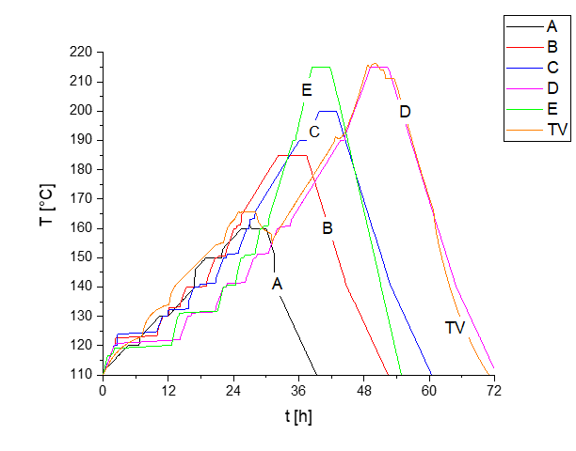
Figure 1. Temperature profiles of the thermal treatments.

batch | T_{max} [°C] | H₁₃₂ [h∙°C] | ML % (ash) | ML % (beech) | ML % (oak) | ML % (Tulipier) | ML % (spruce) | ML % (pine)
A | 160 | 362 | 0.8 | 1.0 | 2.1 | 1.1 | 0.9 | 1.0
B | 185 | 972 | 4.3 | 3.1 | 5.3 | 3.1 | 2.1 | 2.6
C | 200 | 1397 | 8.8 | 6.7 | 8.7 | 6.2 | 3.4 | 4.3
D | 215 | 1858 | 13.1 | 12.2 | 11.9 | 11.1 | 6.1 | 6.6
E | 215 | 1307 | 12.0 | 9.9 | 12.0 | 9.9 | 5.7 | 5.7
TV | 215 | 1845 | 12.6 | 10.0 | 12.4 | 10.0 | 6.2 | 7.0
Table 1. Process parameters and final mass loss

The SW modification batches named A, B, C, D have different T_{max} (160°, 185°, 200° and 215° C). The SW modification batches named E has the same T_{max} of D (215° C) but faster T rate during heating. The TV modification batch has the same T_{max} (215 °C) and same H of SW batches named D. In the framework of such experimental matrix, batches A, B, C, D allow to evaluate the influence of T_{max}; batches D and E allow to evaluate the influence of time and batches D and TV the differences between SW and TV.

Wood sampling

Each treatment batch was composed of approximately 1 m³ of sawn boards (30-mm thick) of six species, which are among the most widespread on the TMW market for furniture, flooring, joinery, and decking (Table 2).

Species | Species ID | Oven-dry density | Notes
Norway spruce (Picea abies Karst) | AR | 388 kg m⁻³ | S
Scots pine (Pinus sylvestris L.) | PS | 592 kg m⁻³ | S, d
Beech (Fagus selvatica L.) | FG | 690 kg m⁻³ | H
Ash (Fraxinus spp.) | FR | 707 kg m⁻³ | H
Oak (Quercus spp.) | RV | 745 kg m⁻³ | H, d
Tulipier (Liriodendron tulipifera) | TP | 537 kg m⁻³ | H, d
Table 2. Tree species of origin of the TMW samples (S: softwood; H: hardwood, d: species with differentiated heartwood).

A portion of the board of each species was kept untreated as a reference.
The mass of each treated board was measured oven dried before the treatment (M₀) and after the treatment (M_{ht}) and the mass loss was calculated as:
$ML=\frac{(M_{0}-M_{ht})}{M_{0}}\%$.
After the treatment, in order to minimize the effect of time on emissions, sampled treated boards and the reference boards (1+1 boards from each species) have been conditioned for about two months in a climatic chamber at RH 65%, T 20 °C. After the conditioning, the equilibrium moisture content of wood was about 12% in untreated samples and about 6% in treated samples. Such reduced hygroscopicity is peculiar of thermally modified wood and it is due to the thermal degradation of hemicellulose and cellulose of the cell walls.
Five mm of thickness were removed from the external surface. In addition, some shavings from the last planer step to a depth of 55 mm were collected and immediately placed in a clear vial and capped.

PTR-ToF-MS measurements

All measurements were performed by using a commercial PTR-ToF-MS 8000 instrument (Ionicon Analytik GmbH, Innsbruck, Austria). The ionisation conditions were the following: 560 V drift voltage, 110 °C drift temperature, and 2.80 mbar drift pressure, resulting in an E/N ratio of 130 Td. Data acquisition was set to record one mass spectrum per second. Inlet flow was set to 40 sccm.
Three replicates of 0.5 grams of each sample were placed into a 20-ml screw-capped clear vial (Supelco, Bellefonte, US). The vials were equilibrated at 40°C for 30 min before the analysis. Each measurement was the averaged result of 30 seconds of acquisition. A multipurpose autosampler (Gerstel GmbH, Mulheim am Ruhr, Germany) was used to perform headspace analysis in automated manner.

Data extraction and analysis

Dead time correction, internal calibration of PTR-ToF-MS data and subsequent peak extraction steps were performed according to procedures described elsewhere [25,26] to reach in most cases a mass accuracy ≤0.001 Th, which is sufficient for sum formula determination. The baseline of the mass spectra was removed after averaging the whole measurement and peak detection and peak area extraction was performed by using a modified Gaussian to fit the data. Whenever a peak was detected, the volatile concentrations were calculated directly via the amount of detected ions in ppbV (part per billion in volume) levels according to the formulas described by Lindinger et al. (1998) by assuming a constant reaction rate coefficient (k_{R}=2×10⁻⁹ cm³/s). Mass spectra were recorded in the range 15-300 Th mass-to-charge ratio. PTR-ToF-MS data processing and statistical analyses were performed by using software packages and scripts developed in-house in MATLAB (MathWorks, Natick, MA) and R Programming Language [28].

Results and discussion

Overall, the sample set consisted of six different tree species submitted to six different treatments or untreated. Whenever possible, samples originating from different wood types of the same species (i.e. heartwood vs. sapwood) were separately processed and characterised. The characteristics of the sample set are summarised in Table 3.
Tree species | Wood type | Treatments
Tree species | Wood type | NT | A | B | C | D | E | TV
AR | Whole | X | x | x | x | x | x | x
PS | Whole | n.a. | n.a. | n.a. | n.a. | n.a. | n.a. | x
PS | Sapwood | X | x | x | x | x | x | n.a.
PS | Heartwood | X | x | x | x | x | x | n.a.
FG | Whole | X | x | x | x | x | x | x
FR | Whole | X | x | x | x | x | x | x
RV | Whole | n.a. | x | n.a. | n.a. | x | n.a. | X
RV | Sapwood | X | n.a. | x | x | n.a. | x | n.a.
RV | Heartwood | X | n.a. | x | x | n.a. | x | n.a.
TP | Whole | n.a. | x | n.a. | n.a. | n.a. | n.a. | x
TP | Sapwood | X | n.a. | x | x | x | x | n.a.
TP | Heartwood | X | n.a. | x | x | x | x | n.a.
Table 3. Sample set: available samples grouped according to tree species, wood type and treatment (x=available, n.a.=not available).

The whole PTR-ToF-MS dataset consisted of 289 and 300 mass peaks for softwood and hardwood, respectively. After additional inspection of the dataset, mass peaks with headspace concentration < 1 ppbV were excluded, along with redundant data (¹³C isotopologues and water adducts). This eventually resulted in 99 mass peaks, common to both hardwood and softwood. For some very abundant VOCs, signal saturation of the ¹²C isotopologue mass peak was observed: we therefore used the ¹³C isotopologue and used theoretical isotopic abundance to extrapolate the actual headspace concentration.
Figure 2 provides a graphic representation (heatmap) of all VOC profiles, where samples and mass peaks are grouped by means of hierarchical cluster analysis and sorted accordingly. In the heatmap, closely clustered columns represent wood samples that are similar in terms of VOC emission. A major separation is highlighted between untreated and treated samples, placed on the left- and right-hand side of the heatmap, respectively. This is not surprising, since during thermal treatment, several processes take place modifying the release profile: some VOCs are lost or reduced by evaporation, while others are increased as a result of an improved extractability from the wood tissue or generated ex-novo by thermally induced transformation of non-volatile wood compounds.
Looking at unmodified wood samples (NT), these can be roughly subdivided into softwood (AR, PS) and hardwood (FG, FR, RV,TP) based on their VOC profiles, with the former displaying higher overall emission. As for TMW, cluster analysis also highlights the separation between softwood and hardwood. The evolution of VOC profiles with thermal treament is in agreement with literature [6]: in softwood some VOCs decrease while others increase whereas in hardwood, which had lower overall emissions, several VOCs increase significantly.
In order to support accurate mass-based tentative identification of the VOCs obtained in the wood sample headspace using PTR-ToF-MS, we conducted cross-platform validation using SPME-GC-MS on a subset of the samples. Whenever possible, SPME-GC-MS data was used to support tentative identifications: a complete list of the mass peaks with respective tentative identifications is supplied in Supplementary – S1.

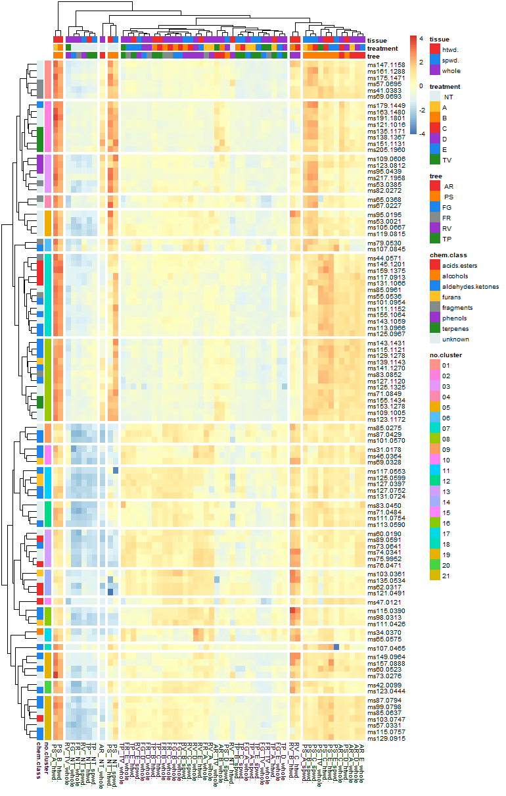
Figure 2. Heatmap of wood headspace VOC profiles. Data are log transformed, autoscaled and centered. Rows represent mass peaks and columns represent samples, averaged over all analytical replicates.
In the heatmap, closely clustered rows represent VOCs that display similar behaviour across all samples. Interestingly, VOCs belonging to the same chemical class are often clustered together or occupy neighbouring clusters: this indicates that compounds that are chemically alike respond similarly to thermal treatment, and possibly have similar origin. Looking at the cluster structure, a subdivision into two major groups can be highlighted, occupying the upper and bottom half of the heatmap, respectively. Within each of these large subdivisions, minor groupings could be higlighted: these were labelled clusters 1-21 in Figure 2 and are referred as such. In the following paragraphs, the behaviour of the different VOCs according to the respective chemical classes is discussed: a list of represetnative mass peaks with the respective tentative identifications is provided in Table 4 and for some of these mass peaks, boxplot representations of the results are provided in Figure 3 and Figure 4. The complete results are instead provided in Supplementary – S2.
The upper half of the heatmap (Figure 2, clusters 1-8) includes compounds that are more concentrated in softwood, in either NT or TMW, or in both.
Cluster 2 contains several mass peaks which can be assigned to terpenes. In coniferous species these compounds are stored in resin canals, where they remain readily accessible [29] and make up most of softwood VOC emission profile; this is not observed for deciduous tree species, which instead lack resin canals. Thanks to terpenes, softwood gives of a pleasant smell that has been reported to improve mood and reduce stress [30] even though desirable properties must be carefully weighed against potentially harmful effects as terpenes are known irritants and the EU includes them in the list of compounds of potential concern for construction material emission. Mass peak m/z 138.137 represents the sum of monoterpenes. We observe that in Scots pine monoterpenes alone account for more than 80% of total emission; their levels remain relatively unaltered in the range T = 160-185 °C, showing a sharp drop of two orders of magnitude when T = 200-215 °C (Figure 3). It is well known that thermal treatment speeds up the release of terpenes from wood, causing a drop in their emission [31]. In Norway spruce any thermal treatment always results in a significant decrease in terpene emissions with the exception of T = 200 °C (treatment C). Mass peak m/z 205.196 is also relevant to terpene chemistry as it can be assigned to sesquiterpenes, which can be detected in high concentration in the headspace of softwood samples and react to thermal treatment similarly to monoterpenes (Supplementary - S2). In a previous research work [21] conducted using PTR-ToF-MS on untreated wood cores, mass peaks m/z 137 and 205 were also found to be important in discriminating coniferous and deciduous species. As for hardwood, mono- and sesquiterpene peaks are detectable, but at levels typically 100,000-fold lower than those observed for softwood. These are likely due to negligible cross contaminations between different sample types, that possibly occurred during preparation. PTR-ToF-MS does not allow for the speciation of terpenes, unless a GC separation step is coupled to it [32]. Based on SPME-GC-MS data, mass peak m/z 138.137 can be associated to monoterpenes alpha- and beta-pinene, camphene, D-limonene and delta-carene and mass peak m/z 205.196 to sesquiterpenes alpha-muurolene, beta-isocaryophyllene and longifolene (Supplementary – S2).
Volatile phenols are found in cluster 5. Their emissions are expected to increase as a result of thermal degradation of lignin. Phenol and structurally related compounds are measured in the headspace of thermally treated white poplar [11], Chinese white poplar [16] and Tunisian softwood species [33]. Among all volatile phenols, phenol presents the highest toxicological concern with documented adverse effects on exposed workers [34]. PTR-ToF-MS detected mass peaks m/z 95.044 (phenol), m/z 109.061 (2-methyl-phenol) and m/z 123.081 (2,3-methyl-phenol). Figure 3 shows headspace concentration of 2,3-methyl-phenol across all samples: in NT wood, PS shows the highest concentrations; indeed, volatile phenols have been reported as odor-active compounds in untreated Scots pine [35]. Untreated hardwood displayed instead very low (< 1 ppbV) volatile phenol emissions whereas in TMW, phenol concentration dependency on temperature followed a bell-shaped curve, peaking at T = 180-200 °C (B-C) and decreasing for T = 215 °C (D).
PTR-ToF-MS also detected mass peaks corresponding to several aliphatic aldehydes and ketones from C6 to C9 (cluster 7-8 in Figure 2 and Table 4), and C6-C9 carboxylic acids (cluster 7 in Figure 2 and Table 4). When long-chain fatty acids undergo autoxidation, the generation of a wide range of volatile aldehydes is to be expected; aldehydes then undergo further oxidation into carboxylic acids [36]. In wood VOC emission studies, hexanal is most commonly detected whereas aldehydes with more than six carbon atoms are only rarely reported [16,33]. Little information is available about the corresponding carboxylic acids. Even though the impact of these aldehydes and acids is minor from the human exposition standpoint, the fact that they are consistently detected in wood samples from several tree species extends our current knowledge on wood VOC emission and provides a window into wood thermal degradation kinetics. Aldehydes/ketones and acids are more concentrated in softwood than in hardwood. Figure 3 graphically represents the results for hexanal (m/z 101.095) and hexanoic acid (m/z 117.091). Hexanal release is significantly affected by thermal treatment in 5 out of 6 tree species, whereas for hexanoic acid the effect is less evident: this likely reflects the fatc that aldehydes are more volatile than the corresponding acids.
The lower half of the heatmap (Figure 2, clusters 9-21) includes compounds whose concentration is similar for both softwood and hardwood, and increases following thermal treatment.
Similar trends are observed for formic acid (m/z 47.012, cluster 15 in Figure 2 and Figure 4), and acetic acid (m/z 62.032, cluster 14). Formic acid -even though its formation can be expected from wood thermal tratment- is poorly reported. In fact, it is difficult to analyse formic acid by TD-GC-MS due to the high volatility of this compound. PTR-ToF-MS allows to bypass this problem. Acetic acid comes from the degradation of hemicelluloses and lignin. This VOC is well-represented in terms of relative abundance within the headspace of untreated wood, reaching 60% of total VOC emission in NT oak. Looking at NT samples only, oak and tulipier show the highest acetic acid release: this is likely related to the fact that in hardwood lignin and hemicelluloses show a higher degree of acetylation [5,12,37,38].
Formaldehyde (m/z 31.018, cluster 10 in Figure 2 and Figure 4) is often reported as wood VOC and it is formed following the degradation of lignin and polysaccharides. Formaldehyde is a recognised carcinogen [39] and therefore rises the most seroius health concerns among all wood VOCs. Standard methods have been developed for formaldehyde determination in construction materials, which require derivatisation, followed by liquid chromatography or photometric determination [40]. As previously stated, TD-GC-MS is not suited to formaldehyde determination; therefore, the fact that PTR-ToF-MS allows to measure it in direct, sensitive and rapid fashion is of particular interest: formaldehyde quantification by PTR-MS is possible, provided the relative humidity of the sample is known [41]. In our dataset, important differences in formaldehyde emission among tree species were highlighted (high emission in AR, PS, RW, and TP while low emission in FG and FR). Concentrations readily increased upon heating in TMW, starting from T = 160 °C. Interestingly, PTR-ToF-MS was also capable to directly determine acetaldehyde (m/z 46.036, cluster 10) and methanol (m/z 34.037, cluster 17), which like formaldehyde are toxic and not easy to detect by TD-GC-MS.
Cluster 16 contains furfural (m/z 98.031, Figure 4) and 5-methyl-furfural (m/z 111.043). These are well-known products of thermal degradation of hemicellulose and increase upon thermal treatment in both hardwood and softwood [10,16,33]. Relatively weak evidence of carcinogenicity is reported for furfural [42]. Our results confirm a strong dependency on temperature for furfural and 5-methyl-furfural formation: release peaks at T = 180 – 200 °C, but 160 °C is enough to elicit a sharp increase with respect to NT samples. Oak shows the highest levels among the tested tree species.

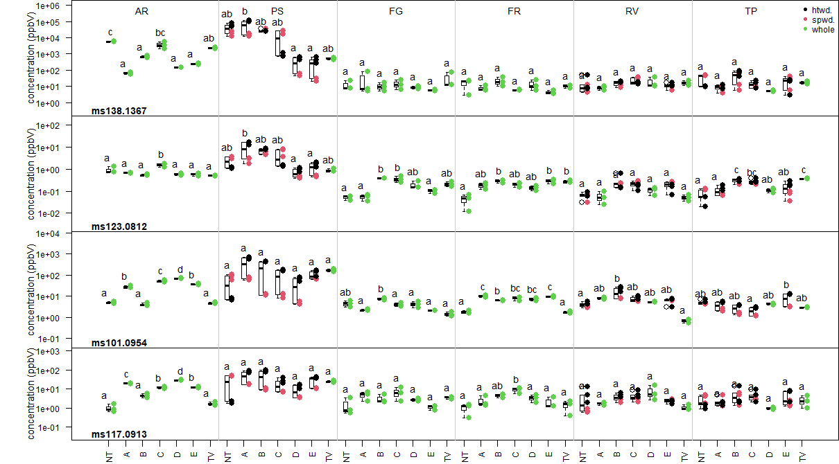

Figure 3. Boxplots for selected mass peaks. Letters indicate significant differences (Tukey’s post-hoc test, p < 0.01).
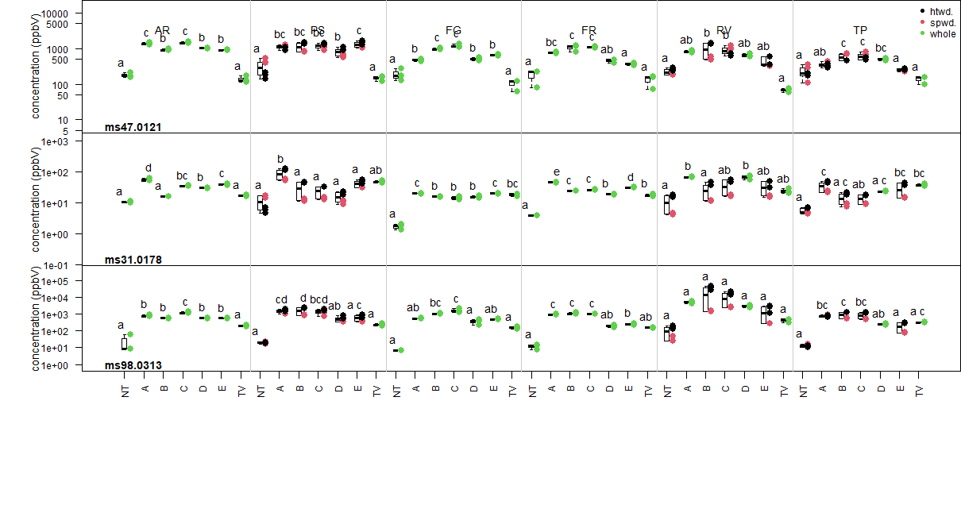
Figure 4. Boxplots for selected mass peaks. Letters indicate significant differences (Tukey’s post-hoc test, p < 0.01).
Mass peak |  | Sum formula | Tentative identification
Meas. Mass | Theor. mass | Sum formula | Tentative identification
138.137 | 138.136 | [C₉¹³CH₁₆]H⁺ | monoterpenes
205.196 | 205.195 | [C₁₅H₂₄]H⁺ | sesquiterpenes
95.044 | 95.049 | [C₆H₆O]H⁺ | Phenol
109.061 | 109.065 | [C₇H₈O]H⁺ | 2-methyl-phenol
123.081 | 123.080 | [C₈H₁₀O]H⁺ | 2,3-methyl-phenol
101.095 | 101.096 | [C₆H₁₂O]H⁺ | hexanal
115.112 | 115.112 | [C₇H₁₄ O]H⁺ | 2-heptanone
127.112 | 127.112 | [C₈H₁₄O]H⁺ | 2-(E)-octenal
141.127 | 141.127 | [C₉H₁₆O]H⁺ | 2-(E)-nonenal
143.143 | 143.143 | [C₉H₁₈O]H⁺ | Nonanal
117.091 | 117.091 | [C₆H₁₂O₂]H⁺ | hexanoic acid
131.107 | 131.107 | [C₇H₁₄O₂]H⁺ | heptanoic acid
145.120 | 145.122 | [C₈H₁₆O₂]H⁺ | octanoic acid
159.137 | 159.138 | [C₉H₁₈O₂]H⁺ | nonanoic acid
47.012 | 47.013 | [CH₂O₂]H⁺ | formic acid
62.032 | 62.032 | [C¹³CH₄O₂]H⁺ | acetic acid
31.018 | 31.018 | [CH₂O]H⁺ | formaldehyde
46.036 | 46.037 | [C¹³CH₄O]H⁺ | acetaldehyde
34.037 | 34.037 | [¹³CH₄O]H⁺ | methanol
98.031 | 98.032 | [C₄¹³CH₄O₂]H⁺ | furfural
111.043 | 111.044 | [C₆H₆O₂]H⁺ | 5-methyl-furfural
Table 4. Mass peaks mentioned in the text, with the corresponding tentative identifications. Highlighted mass peaks are also represented in Figure 3 or Figure 4.

In Scots pine (PS) and oak (RV), heartwood and sapwood were sampled separately. In either case, there is a striking difference in VOC release between wood types. The heatmap (Figure 2) shows that for untreated PS and RV heartwood and sapwood cluster together but in TMW heartwood and sapwood behave differently. For heartwood PS, treatments A and B (T = 160 and 180 °C) show high release for many VOCs, in particular terpenes, phenols, fatty acids and aldehydes (including formaldehyde). Heartwood RV treatments B and C (T = 180 and 200 °C) form a separate cluster from all other hardwood samples (Figure 2), displaying higher than average VOC release, particularly for acetic acid and furfural (Figure 4).
Previous research [9,43] has already highlighted that Scots pine heartwood releases more VOCs than sapwood, probably as a result of a higher extractive content. Less information is instead available on difference in VOC release in deciduous trees according to tissue type and the findings reported in this work strongly support the choice of oak TMW sapwood over hardwood as construction material.
Finally, the effect of some technological parameters was investigated. The Styl⁺wood® (SW) process with T_{max} = 215 °C (treatment D) was compared with the Thermo-vacuum® process (TV) using the same temperature ramp. Previous work [22] shows that TV affords materials with improved properties in terms of dimensional stability and durability. PTR-ToF-MS analysis reveals several significant differences in VOC release between TV and SW, but results are often species-dependent. For example, TV, which is an open system, is more effective in reducing the generation of acetic acid in all tree species except TP and formaldehyde in AR and RV, whereas for furfural TV is more effective than SW in AR, less effective in TP (Figure 4). A comparison of SW treatment E with treatment D (same T_{max} = 215 °C but faster ramp, Figure 1). was carried out with the purpose to examine the effect on VOC release of fine tuning parameter of the Styl⁺wood® process. In this case, the impact of the faster temperature ramp is minimal and in cluster analysis D and E samples from the same tree species always appear closely grouped (Figure 2).
In the present work, an extensive PTR-ToF-MS profiling was carried out on shavings from six different wood species under native conditions and after six different types of thermal treatment. This is the first example of the use of PTR-
ToF-MS for the analysis thermally modified wood. The rapidity of analysis allowed to perform comparisons across a relatively large sample set, combining different tree species and treatments. The effect of some variables, such as the use of vacuum, changes depending on the tree species it is applied to; therefore, results obtained on a single tree species cannot always be extrapolated to all types of wood: this further substantiates the usefulness of high-throughput analytical techniques, allowing to measure rapidly large sample sets and thus evaluate the effect of combinations of several parameters.
The capability of PTR-ToF-MS to directly determine some very volatile compounds, such as formaldehyde, is also noteworthy, as the measurement of such compounds normally calls for dedicated methods, requiring complex sample preparation. Overall, the results support the use of PTR-ToF-MS as a high-throughput screening tool for material emission studies, in a role complementary to more time-consuming TD-GC-MS. Future developments in this line of research might involve exploiting some additional capabilities of PTR-ToF-MS such as the possibility to monitor VOC emissions in real time during the thermal treatment process on the chimney with the aim to control pollution or to optimise process parameters, as well as VOC monitoring from TMW on a post-production line for quality inspection and labelling. The aim of the work was to explore the use of PTR-ToF-MS as an analytical technique to detect and discriminate the relative quantity and quality of VOC compounds that are known to be emitted from natural and thermally modified wood. The results show that the speed and cost-effectiveness of PTR-ToF-MS, together with a more extensive and targeted sampling design and a consequent more robust statistical model, could be used for control of emissions of TMW process and product for various purposes, including environmental and human health protection and quality control.

Acknowledgments
This project was economically supported by Veneto Region in the framework of POR-CRO call FESR 2014/2020 STYL+WOOD project and by the Autonomous Province of Trento (ADP 2022).
References

[1] T. Adamová, J. Hradecký, M. Pánek, Volatile Organic Compounds (VOCs) from Wood and Wood-Based Panels: Methods for Evaluation, Potential Health Risks, and Mitigation, Polymers. 12 (2020) 2289. https://doi.org/10.3390/polym12102289.
[2] Z. Liu, J.C. Little, Materials responsible for formaldehyde and volatile organic compound (VOC) emissions, in: Toxic. Build. Mater., Elsevier, 2012: pp. 76–121. https://doi.org/10.1533/9780857096357.76.
[3] F. Bulian, C. Fragassa, VOC emissions from wood products and furniture: A survey about legislation, standards and measures referred to different materials, FME Trans. 44 (2016) 358–364. https://doi.org/10.5937/fmet1604358B.
[4] L.K. Jensen, A. Larsen, L. M⊘lhave, M.K. Hansen, B. Knudsen, Health Evaluation of Volatile Organic Compound (VOC) Emissions from Wood and Wood-Based Materials, Arch. Environ. Health Int. J. 56 (2001) 419–432. https://doi.org/10.1080/00039890109604477.
[5] M. Risholm-Sundman, M. Lundgren, E. Vestin, P. Herder, Emissions of acetic acid and other volatile organic compounds from different species of solid wood, Holz Als Roh- Werkst. 56 (1998) 125–129. https://doi.org/10.1007/s001070050282.
[6] J. Pohleven, M. Burnard, A. Kutnar, VOLATILE ORGANIC COMPOUNDS EMITTED FROM UNTREATED AND THERMALLY MODIFIED WOOD - A REVIEW, Wood Fiber Sci. 51 (2019) 231–254. https://doi.org/10.22382/wfs-2019-023.
[7] C.A.S. Hill, Wood modification: chemical, thermal and other processes, John Wiley & Sons, Chichester, England ; Hoboken, NJ, 2006.
[8] A.-M. Manninen, P. Pasanen, J.K. Holopainen, Comparing the VOC emissions between air-dried and heat-treated Scots pine wood, Atmos. Environ. 36 (2002) 1763–1768. https://doi.org/10.1016/S1352-2310(02)00152-8.
[9] H. Sivrikaya, D. Tesařová, E. Jeřábková, A. Can, Color change and emission of volatile organic compounds from Scots pine exposed to heat and vacuum-heat treatment, J. Build. Eng. 26 (2019) 100918. https://doi.org/10.1016/j.jobe.2019.100918.
[10] C. Wang, Z. Wang, Y. Qin, X. Yin, A. Huang, Released Volatile Organic Compounds in Southern Yellow Pine before and after Heat Treatment, Int. J. Environ. Res. Public. Health. 15 (2018) 2579. https://doi.org/10.3390/ijerph15112579.
[11] P. Čech, Comparison of VOC Emissions from Natural Wood and Heat Treated Wood, Drv. Ind. 69 (2018) 297–309. https://doi.org/10.5552/drind.2018.1708.
[12] M. Hyttinen, M. Masalin-Weijo, P. Kalliokoski, P. Pasanen, Comparison of VOC emissions between air-dried and heat-treated Norway spruce (Picea abies), Scots pine (Pinus sylvesteris) and European aspen (Populus tremula) wood, Atmos. Environ. 44 (2010) 5028–5033. https://doi.org/10.1016/j.atmosenv.2010.07.018.
[13] ISO 16000 Part 9 - Determination of the emission of volatile organic compounds from building products and furnishing — Emission test chamber method, International Organization for Standardization (ISO), Geneva, Switzerland, 2006.
[14] ISO 16000 Part 10 - Determination of the emission of volatile organic compounds from building products and furnishing — Emission test cell method, International Organization for Standardization (ISO), Geneva, Switzerland, 2006.
[15] L. Culleré, B. Fernández de Simón, E. Cadahía, V. Ferreira, P. Hernández-Orte, J. Cacho, Characterization by gas chromatography–olfactometry of the most odor-active compounds in extracts prepared from acacia, chestnut, cherry, ash and oak woods, LWT - Food Sci. Technol. 53 (2013) 240–248. https://doi.org/10.1016/j.lwt.2013.02.010.
[16] L. Xue, Z. Zhao, Y. Zhang, D. Chu, J. Mu, Analysis of gas chromatography-mass spectrometry coupled with dynamic headspace sampling on volatile organic compounds of heat-treated poplar at high temperatures, BioResources. 11 (2016) 3550–3560.
[17] M.C. Díaz-Maroto, E. Sánchez-Palomo, M.S. Pérez-Coello, Fast Screening Method for Volatile Compounds of Oak Wood Used for Aging Wines by Headspace SPME-GC-MS (SIM), J. Agric. Food Chem. 52 (2004) 6857–6861. https://doi.org/10.1021/jf049032m.
[18] N. Natali, F. Chinnici, C. Riponi, Characterization of Volatiles in Extracts from Oak Chips Obtained by Accelerated Solvent Extraction (ASE), J. Agric. Food Chem. 54 (2006) 8190–8198. https://doi.org/10.1021/jf0614387.
[19] R. Fedele, I.E. Galbally, N. Porter, I.A. Weeks, Biogenic VOC emissions from fresh leaf mulch and wood chips of Grevillea robusta (Australian Silky Oak), Atmos. Environ. 41 (2007) 8736–8746. https://doi.org/10.1016/j.atmosenv.2007.07.037.
[20] MDHS 72: Volatile organic compounds in air. Laboratory method using pumped solid sorbent tubes, thermal desorption and gas chromatography, (1992). www.hse.gov.uk/pubns/mdhs/.
[21] C. Taiti, C. Costa, W. Guidi Nissim, S. Bibbiani, E. Azzarello, E. Masi, C. Pandolfi, F. Pallottino, P. Menesatti, S. Mancuso, Assessing VOC emission by different wood cores using the PTR-ToF-MS technology, Wood Sci. Technol. 51 (2017) 273–295. https://doi.org/10.1007/s00226-016-0866-5.
[22] O. Allegretti, M. Brunetti, I. Cuccui, S. Ferrari, M. Nocetti, N. Terziev, Thermo-vacuum modification of spruce (Picea abies karst.) and fir (Abies alba mill.) wood, BioResources. 7 (2012) 3656–3669.
[23] O. Allegretti, I. Cuccui, N. Terziev, L. Sorini, A model to predict the kinetics of mass loss in wood during thermo-vacuum modification, Holzforschung. 75 (2021) 474–479. https://doi.org/10.1515/hf-2020-0127.
[24] K. Candelier, M.-F. Thevenon, A. Petrissans, S. Dumarcay, P. Gerardin, M. Petrissans, Control of wood thermal treatment and its effects on decay resistance: a review, Ann. For. Sci. 73 (2016) 571–583. https://doi.org/10.1007/s13595-016-0541-x.
[25] L. Cappellin, F. Biasioli, A. Fabris, E. Schuhfried, C. Soukoulis, T.D. Märk, F. Gasperi, Improved mass accuracy in PTR-TOF-MS: Another step towards better compound identification in PTR-MS, Int. J. Mass Spectrom. 290 (2010) 60–63. https://doi.org/10.1016/j.ijms.2009.11.007.
[26] L. Cappellin, F. Biasioli, P.M. Granitto, E. Schuhfried, C. Soukoulis, F. Costa, T.D. Märk, F. Gasperi, On data analysis in PTR-TOF-MS: From raw spectra to data mining, Sens. Actuators B Chem. 155 (2011) 183–190. https://doi.org/10.1016/j.snb.2010.11.044.
[27] W. Lindinger, A. Hansel, A. Jordan, On-line monitoring of volatile organic compounds at pptv levels by means of Proton-Transfer-Reaction Mass Spectrometry (PTR-MS) Medical applications, food control and environmental research, Int. J. Mass Spectrom. Ion Process. 173 (1998) 191–241. https://doi.org/10.1016/s0168-1176(97)00281-4.
[28] R Core Team, R: A Language and Environment for Statistical Computing, R Foundation for Statistical Computing, Vienna, Austria, 2022. https://www.R-project.org/.
[29] E.L. Back, Pattern of parenchyma and canal resin composition in softwoods and hardwoods, J. Wood Sci. 48 (2002) 167–170. https://doi.org/10.1007/BF00771362.
[30] E. Matsubara, S. Kawai, VOCs emitted from Japanese cedar (Cryptomeria japonica) interior walls induce physiological relaxation, Build. Environ. 72 (2014) 125–130. https://doi.org/10.1016/j.buildenv.2013.10.023.
[31] F. Kačík, V. Veľková, P. Šmíra, A. Nasswettrová, D. Kačíková, L. Reinprecht, Release of Terpenes from Fir Wood during Its Long-Term Use and in Thermal Treatment, Molecules. 17 (2012) 9990–9999. https://doi.org/10.3390/molecules17089990.
[32] D. Materić, M. Lanza, P. Sulzer, J. Herbig, D. Bruhn, C. Turner, N. Mason, V. Gauci, Monoterpene separation by coupling proton transfer reaction time-of-flight mass spectrometry with fastGC, Anal. Bioanal. Chem. 407 (2021). https://doi.org/10.1007/s00216-015-8942-5.
[33] M. Elaieb, K. Candelier, A. Pétrissans, S. Dumarçay, P. Gérardin, M. Pétrissans, Heat treatment of Tunisian soft wood species: Effect on the durability, chemical modifications and mechanical properties, Maderas Cienc. Tecnol. (2015) 0–0. https://doi.org/10.4067/S0718-221X2015005000061.
[34] M.Y. Shamy, R.M.E. Gazzar, M.A.E. Sayed, A.M. Attia, Study of Some Biochemical Changes among Workers Occupationally Exposed to Phenol, Alone or in Combination with Other Organic Solvents., Ind. Health. 32 (1994) 207–214. https://doi.org/10.2486/indhealth.32.207.
[35] L. Schreiner, P. Bauer, A. Buettner, Resolving the smell of wood - identification of odour-active compounds in Scots pine (Pinus sylvestris L.), Sci. Rep. 8 (2018) 8294. https://doi.org/10.1038/s41598-018-26626-8.
[36] M. Gabriel, S. Paczkowski, S. Nicke, S. Schütz, C. Behn, R. Kraft, E. Roffael, Effect of some treatments on emission of volatile organic compounds (VOC) from chips used in pellets making processes, Int. Wood Prod. J. 6 (2015) 60–68. https://doi.org/10.1179/2042645314Y.0000000091.
[37] F. Englund, Emissions of volatile organic compounds (VOC) from wood, Tratek, Swedish Institute for Wood Technology Research, Stockholm, Sweden, 1999.
[38] J. Peters, K. Fischer, S. Fischer, Characterization of emissions from thermally modified wood and their reduction by chemical treatment, BioResources. 3 (2008) 491–502.
[39] International Agency for Research on Cancer, ed., Formaldehyde, 2-Butoxyethanol and 1-tert-Butoxypropan-2-ol: this publication represents the views and expert opinions of an IARC Working Group on the Evaluation of Carcinogenic Risks to Humans, which met in Lyon, 2 - 9 June 2004, IARC, Lyon, 2006.
[40] M. Risholm-Sundman, A. Larsen, E. Vestin, A. Weibull, Formaldehyde emission—Comparison of different standard methods, Atmos. Environ. 41 (2007) 3193–3202. https://doi.org/10.1016/j.atmosenv.2006.10.079.
[41] J. Beauchamp, J. Herbig, J. Dunkl, W. Singer, A. Hansel, On the performance of proton-transfer-reaction mass spectrometry for breath-relevant gas matrices, Meas. Sci. Technol. 24 (2013). https://doi.org/10.1088/0957-0233/24/12/125003.
[42] International Agency for Research on Cancer, International Agency for Research on Cancer, Working Group on the Evaluation of Carcinogenic Risks to Humans, eds., Some chemicals that cause tumours of the urinary tract in rodents: views and expert opinions of an IARC Working Group on the Evaluation of Carcinogenic Risks to Humans, wich met in Lyon, 6-13 June 2017, 2019.
[43] M. Czajka, B. Fabisiak, E. Fabisiak, Emission of Volatile Organic Compounds from Heartwood and Sapwood of Selected Coniferous Species, Forests. 11 (2020) 92. https://doi.org/10.3390/f11010092.

