Enhancing Impact Resistance and Thermal Stability of Alkali-Activated Concrete with Nanomaterial Integration: A Sustainable Approach for Construction
Samuvel Raj R, G. Prince Arulraj, *N. Anand, Balamurali Kanagaraj
Division of Civil Engineering, Karunya Institute of Technology and Sciences, Coimbatore, India
Flavio Stochino
Department of Civil Environmental Engineering and Architecture, University of Cagliari, Cagliari, Italy

Abstract
Purpose-This study addresses the urgent need to mitigate carbon dioxide (CO₂)emissions from cement production, emphasizing alkali-activated concrete as an eco-friendly alternative to Ordinary Portland Cement (OPC), offering reduced CO₂ emissions and enhanced mechanical and durability properties. Nanotechnology integration further improves these benefits by fostering sustainability during construction.
Design/methodology/approach-Investigating the effect of various nanomaterials (NMs) (nano-fly ash (nFA), nano-ground granulated blast furnace slag (nGS), and nano-bentonite (nBT)) on the impact resistance of the alkali-activated nano concrete (AANC) impact resistance, exposed to elevated temperatures (200 °C to 800 °C) revealed significant changes in the impact energy, weight loss, failure crack pattern, spalling properties, and capillary water absorption.
Findings-Incorporation of NMs notably influenced the workability, compressive strength (CS), and rebound number of AANC with improvements in CS ranging from 37.25 to 60.37 MPa at 28 days. AANC specimens with NMs exhibited increased cracking resistance and failure impact numbers, with corresponding energy losses after exposure to 800 °C. Elevated temperatures affected the capillary water absorption rates, with higher rates observed for the nBT-added specimens. Scanning electron microscopy (SEM) images depict the microstructural changes, including micro cracks and phase decomposition. The development of predictive models for impact energy and residual impact energy demonstrated good agreement between the experimental and theoretical data (R² values: 0.91–0.95).
Originality/values-Overall, this study revealed the enhancement of the impact resistance and thermal stability of the incorporation of NMs, offering significant implications for sustainable construction practices.
Keywords Alkali-activated concrete, elevated temperature, impact strength, Nanomaterials, Post-fire behavior, residual impact energy
Paper type Research paper
- Introduction
The global greenhouse gas emissions are considerably influenced by the cement manufacturing sector, which is estimated to emit 1.45 ± 0.20 GT of carbon dioxide (CO₂) each year (Cost et al., 2024; Jativa et al., 2024). To mitigate these environmental consequences, scientists are investigating substitutes for Ordinary Portland Cement (OPC). Alkali-activated concrete (AAC) is a prospective and environmentally benign substitute that can significantly reduce the release of carbon dioxide through the construction sector (Azar et al., 2024; Yu et al., 2023). AAC is also a more sustainable alternative to traditional concrete, owing to its remarkable mechanical strength and durability (Bezemer et al., 2023; Ojedokun and Mangat, 2023). It can be manufactured using silica-rich and alumina substances, such as industrial residues, such as ground granulated blast-furnace slag (GGBFS) (Rawat et al., 2024) and fly ash (FA) (Lich et al., 2024), as well as natural sources, such as calcined clays (Shobeiri et al., 2023).
AAC is a highly effective material for high-temperature applications such as fire-resistant construction and industrial environments. The chemical composition of these materials determines the thermal stability and resistance of a geopolymer matrix at elevated temperatures (Tu and Zhang, 2023; Yu et al., 2023). The presence of stable phases and absence of materials prone to thermal decomposition contribute to the ability of the material to withstand heat. At elevated temperatures, the geopolymer matrix undergoes physical and chemical transformations including dehydration, pore pressure development, and crystalline phase transitions (Wang et al., 2024). The structural stability of the geopolymer matrix influences its resistance to thermal degradation and retention of mechanical strength. The porosity and permeability of AAC play a crucial role in its resistance to elevated temperatures. Optimizing the pore structure and reducing the permeability can enhance the ability of a material to withstand thermal stresses and prevent damage under fire conditions (Yu et al., 2024b, 2024a).
Nanotechnology, which involves materials with dimensions smaller than hundred nanometers, has revolutionized sectors, such as healthcare, electronics, and energy production. Nanomaterials (NMs) such as nanoparticles, nanotubes, and nanofibers can significantly improve the mechanical properties of alkali-activated concrete (Dahlan, 2021; Sanchez and Sobolev, 2010). These NMs improve the interfacial bonding, leading to higher compressive, tensile, and flexural strengths (FS). They also reduce the pore size and improve the microstructure and resistance to water, chemicals, and aggressive agents. Nanofibers such as carbon nanotubes (CNT) or nanofibers impart toughness and ductility, making concrete more resistant to cracking and dynamic loads (Paruthi et al., 2023). Some NMs, such as alumina or silica nanoparticles, enhance fire resistance by providing thermal insulation and reducing the heat transfer. Some NMs can facilitate self-healing mechanisms, thereby reducing the environmental footprint associated with construction activities (Zaid et al., 2024).
The fracture resistance and impact energy of two-phase fibrous concrete with nanocarbon tubes were studied by Murali et al. (Murali et al., 2022) using varying hammer weights and drop heights. Their study further evaluated the fracture toughness under the mode I, mode III, and mixed-mode (I/III) conditions. The concrete incorporated polypropylene, short steel, and long steel fibers at a dosage of 2.5 % by volume, along with 0.2 % multiwalled carbon nanotubes (MWCNT) by weight of cement. The results showed significant increase in the impact failure values for mixtures with polypropylene, short steel, and long steel fibers compared to the plain mixture, with enhancements of 1444-1700 %, 3156-3786 %, and 4322-5357 %, respectively. Additionally, fibers improved crack development resistance by 46.1-92.2 % for mode I and 16.4-30.0 % for mode III, demonstrating substantial enhancements in fracture resistance.
Zhang et al. (Zhang et al., 2017) examined the influence of hammer weight and drop height on the flexural impact performance of fiber-reinforced concrete. They found that for both steel-and polypropylene fiber-reinforced concrete, the initial and final impact strengths decreased exponentially with increasing drop height. Conversely, the strengths increased with higher hammer weights when the impact energy was constant. Polypropylene fiber-reinforced concrete exhibited brittle fracture under these conditions, while steel fibers improved ductility and impact resistance. Using the ACI 544-2R recommendations, Abid et al. (Abid et al., 2020) conducted drop weight impact experiments on self-compacting concrete strengthened using micro-steel fibers. In comparison to ordinary samples, they discovered that micro steel fibers substantially enhanced the resistance to impact by 150-860 %. The most significant enhancement was observed at a standard drop height and weight of 450 mm and 4.5 kg .
Wang and Chouw (Wang and Chouw, 2017) studied the behavior of coconut fiber-reinforced concrete under impact loading using both single and repeated impact tests. They tested plain concrete and coconut fiber-reinforced concrete cylinders under various impact energies by adjusting their drop height. They investigated the impact force history, changes in Young’s modulus, and dynamic increase factor of coconut fiber-reinforced concrete. Repeated impact tests were used to evaluate the effect of the impact height on the maximum compressive stress and damage patterns. Coconut fiber-reinforced concrete specimens showed interior damage from low impact heights (40 cm) and a reduced elastic modulus. The dynamic increase factor was minimally influenced by the fiber length. Coconut fiber-reinforced concrete demonstrated better resistance to spalling and fragmentation than plain concrete because of the bridging function of the coconut fibers.
The study by Sai Liu et al. (Liu et al., 2018) examined the impact response of basalt textile-reinforced concrete at various velocities and temperatures. The number of basalt textile layers, temperature, impact velocity, and boundary conditions has a substantial effect on the reaction. The research discovered that when the velocities and temperatures increased, the maximum impact force and energy absorption improved. Both were enhanced by the addition of additional layers. According to the research, basalt textile pull-out was the primary mechanism by which specimens under velocities less than 4.62 m/s absorbed kinetic energy, and varying the impact velocities significantly influenced the failure patterns, whereas temperature and boundary conditions had less effect.
The impact strength of concrete is crucial for resisting dynamic loads without fracturing or breaking and for ensuring the safety and integrity of structures such as buildings, bridges, dams, and pavements. A high impact strength delays the formation of cracks and their propagation, enhancing the durability and service life of concrete structures (Murali et al., 2022). Insufficient impact resistance can lead to micro cracks and progressive deterioration, whereas superior strength can withstand extreme events such as earthquakes, hurricanes, or explosions, minimizing the risk of collapse or significant damage (Venkati and Manjulavani, 2024). Concrete floors in industrial environments can withstand impact loads without surface spalling or deterioration, and maintain a safe working environment. High impact strength also prevents surface rutting, cracking, and deterioration, thereby ensuring pavement longevity and smoothness (J. Zhang et al., 2023).
The drop hammer impact test was used to evaluate the impact resistance of the concrete specimens. This involves raising a heavy mass to a specified height and allowing it to fall onto the concrete specimen. The impact energy absorbed during the test indicates the resistance of concrete to sudden dynamic loads (Zhang et al., 2022). Elevated temperature tests on concrete are crucial for understanding its behavior under high-temperature conditions, such as fire exposure. These tests assess the mechanical properties of concrete, such as compressive strength (CS) and durability, and evaluate the structural integrity and stability of concrete structures during and after exposure to fire. The results provide insights into thermal degradation mechanisms, such as moisture loss, aggregate expansion, pore pressure development, and chemical decomposition of hydration products.
This study aimed to enhance the impact strength of AAC by incorporating NMs. While numerous studies have investigated the effects of nanomaterial additives on various properties of AAC, including CS and durability, limited attention has been directed towards systematic assessment of the impact strength at elevated temperatures. The present study aims to modify AAC microstructurally through different NMs to increase its impact strength.
- Experimental Investigation
  - Materials
    - Binder
This study utilized low-calcium FA that meets ASTM C618-12a, 2014 (“ASTM C618–12a, Standard Specification for Coal Fly Ash and Raw or Calcined Natural Pozzolan for Use in Concrete, ASTM International, West Conshohocken, PA, www.astm.org, ASTM Int. 2014,” 2012), primarily composed of alumina and silica, was acquired from Mettur, India. Additionally, Bentonite (BT) and GGBFS were purchased from nearby vendors, with GGBFS meeting ASTM C989, 2005 standards (“Am. Soc. Test. Mater. i (2005) 2–6. www.astm.org.,” n.d.). Figure 1 depicts the oxide composition of GGBFS, BT, and FA, and Figure 2 shows the cumulative particle size distribution of these materials.
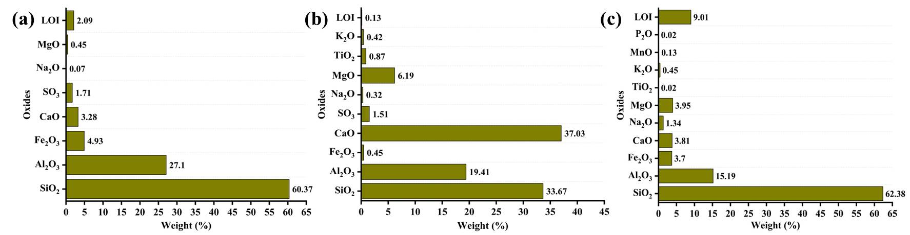
Figure 1. Chemical composition of (a) FA; (b) GGBFS; (c) BT
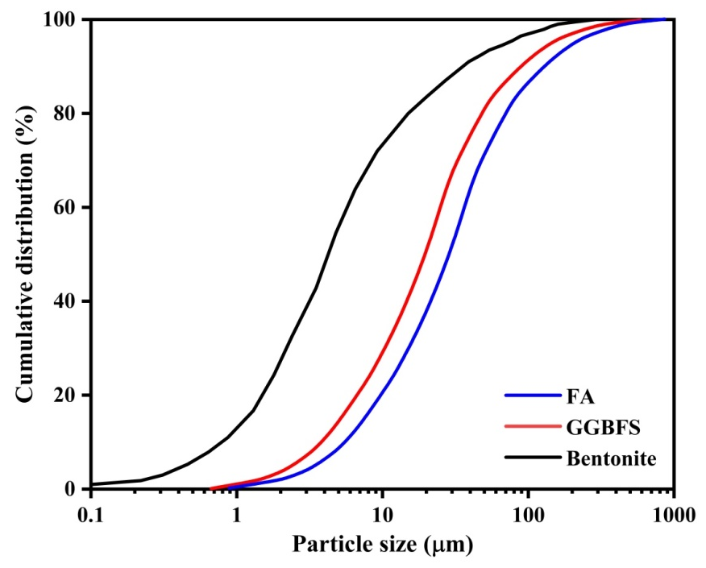
Figure 2. Particle size- Cumulative distribution curve of BT, GGBFS, and FA
According to this study, untreated precursors with inert carbon and contaminants, such as FA, GGBFS, and BT, lost their ignition content. The cross-links in the polymer were broken by this carbon, which had negative effects on carbonation. An electric muffle furnace was used to heat-treat the precursors for two hours at 800 °C in order to resolve these problems. To create excellent binders, the initial components were calcined to convert them into active and stable chemical forms. The untreated precursors were cooled individually after a 24-hour cooling period at ambient temperature.
In this study, nano-fly ash (nFA), nano-ground granulated blast furnace slag (nGS), and nano-bentonite (nBT) were synthesized by pulverizing the precursor materials in a ball mill grinder. The process of powerful ball milling entails the use of a grinding apparatus with a substantial amount of kinetic energy to mechanically alloy and reduce the size of the particles of the substances to nano scale. During this process, the grinding cylinder is subjected to intense mechanical forces, which cause the particulate size to decrease because of frequent effects, abrasion, and distortion. This grinding methodology utilized iron balls within the mill, operating at a speed of 300 rpm for 3, 2, and 1.5 hrs for FA, GGBFS, and BT, respectively.
Table 1 lists the physical characteristics of the precursor and its nano sized variants. The ground FA, GGBFS, and BT produced from the ball mill grinder displayed average particle sizes of 53, 45, and 32 nm, respectively, referred to as nFA, nGS, and nBT, respectively. This is illustrated in Figure 3.

Table 1. Physical properties of binders and its nano-sized varients.
Property | FA | GGBFS | BT | nFA | nGS | nBT
Specific gravity | 2.06 | 2.92 | 2.92 | 2.07 | 2.92 | 2.92
Appearance | Dark gray | White | Brown | Dark gray | White | Brown
Particle size (μm) | 23 | 14 | 4.25 | 0.053 | 0.045 | 0.032
Bulk density (kg/m³) | 890 | 1150 | 871 | 1450 | 1710 | 1431
Specific surface area (m²/kg) | 500 | 610 | 28000 | 465000 | 48950 | 562500

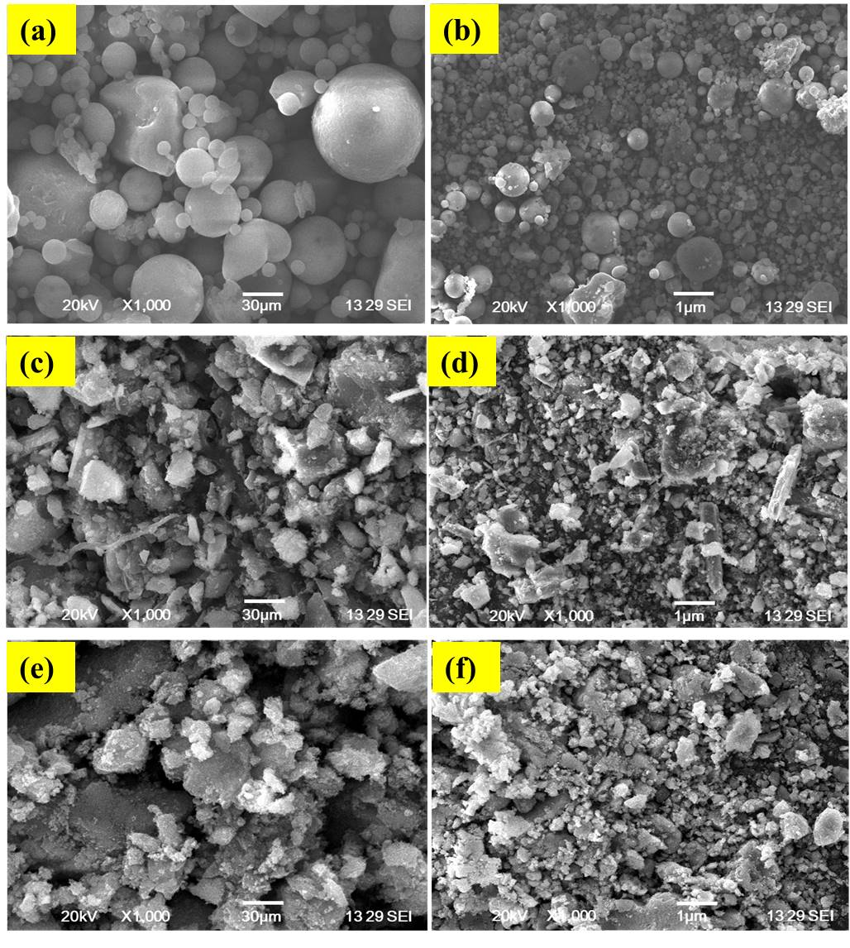
Figure 3. SEM of (a) FA; (b) nFA; (c) GGBFS; (d) nGS; (e) BT; (f) nBT.

    - Filler
This study used traditional crushed stone as the coarse aggregate (CA), with the largest possible particle size of 12.5 mm. Its water absorption (WA) was 0.61 %, and it had a specific gravity of 2.81. The fine aggregate was manufactured sand, which complied with ASTM C33(“Annu. B. ASTM Stand. i (2010) 1–11.,” n.d.) standards, and had a particulate size of less than 4.75 mm. The water absorption, fineness modulus, and specific gravity of the M-sand were found to be 1.37 %, 2.56, and 2.75, respectively. The distributions of the particle sizes for both M-sand and CA are shown in Figure 4.

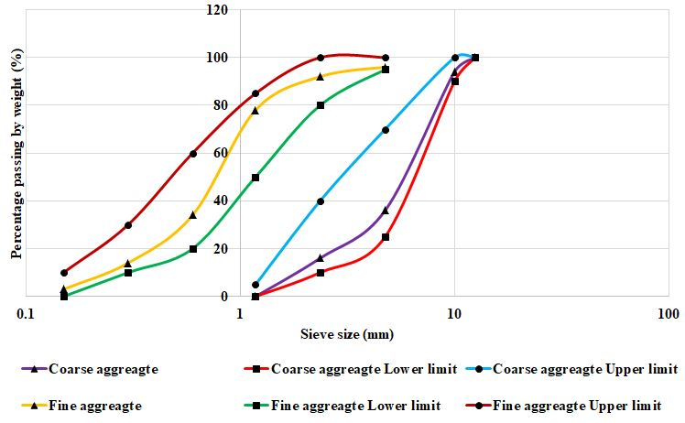
Figure 4. Particle size curve for CA and M-sand

    - Alkaline activators
The experiment utilized a mixture of SS and SH as activators, with SH (purity – 98 %) and SS obtained from a nearby retailer, maintaining a constant SH molarity of 12 M and a 1:2.5 SS to SH ratio.
  - Mix proportion and preparation of specimens
The mix proportions of the alkali-activated nano concrete (AANC) are listed in Table 2. The ratios of fly ash, GGBFS, M-sand, and aggregates were determined as previously described (Raj et al., 2021). The combinations were designated as nMx, where ‘M’ signifies the type of NMs and with ‘x’ denoting the proportion of FA that was supplanted with nGS. The blended precursor was composed in a ratio of 7:3 (i.e., FA: GGBFS). The aggregate-to-precursor ratio was determined as 0.35. To attain the required slump, an extra five percent of the precursor was incorporated.
Table 2. Mix proportions of the AANC with NMs.
Mix ID |  | Binder (kg/m³) |  |  |  | Filler (kg/m³) |  |  | AA (kg/m³)
Mix ID |  | nMx | GGBFS | FA |  | CA | M-sand |  | Na₂SiO₃ | NaOH
nM0 |  | - | 120 | 280 |  | 958 | 625 |  | 168 | 67.2
nFA3 |  | 12 | 120 | 268 |  | 958 | 625 |  | 168 | 67.2
nFA6 |  | 24 | 120 | 256 |  | 958 | 625 |  | 168 | 67.2
nFA9 |  | 36 | 120 | 244 |  | 958 | 625 |  | 168 | 67.2
nFA12 |  | 48 | 120 | 232 |  | 958 | 625 |  | 168 | 67.2
nFA15 |  | 60 | 120 | 220 |  | 958 | 625 |  | 168 | 67.2
nGS3 |  | 12 | 120 | 268 |  | 958 | 625 |  | 168 | 67.2
nGS6 |  | 24 | 120 | 256 |  | 958 | 625 |  | 168 | 67.2
nGS9 |  | 36 | 120 | 244 |  | 958 | 625 |  | 168 | 67.2
nGS12 |  | 48 | 120 | 232 |  | 958 | 625 |  | 168 | 67.2
nGS15 |  | 60 | 120 | 220 |  | 958 | 625 |  | 168 | 67.2
nBT3 |  | 12 | 120 | 268 |  | 958 | 625 |  | 168 | 67.2
nBT6 |  | 24 | 120 | 256 |  | 958 | 625 |  | 168 | 67.2
nBT9 |  | 36 | 120 | 244 |  | 958 | 625 |  | 168 | 67.2
nBT12 |  | 48 | 120 | 232 |  | 958 | 625 |  | 168 | 67.2
nBT15 |  | 60 | 120 | 220 |  | 958 | 625 |  | 168 | 67.2

Initially, the dry components (nM, GGBFS, FA, M sand, and CA) were combined in a cylindrical blender that was equipped with helical propellers. The SH and SS solutions, which were prepared 30 min in advance, were progressively incorporated into the matrix and mixing for two minutes. extra 5 % water compared to the quantity of precursor was added to guarantee an even mix, and the combined process was maintained for an additional three minutes. An impact specimen mold with a diameter of 150 mm and a height of 64 mm and metallic cube molds (150 mm × 150 mm × 150 mm) were used to conduct the CS, Rebound hammer (RH) number, and impact strength tests. The molds were filled in three layers, each compacted until the mixture settled uniformly, and thoroughly shaken for uniform compaction. After one day, the samples were demolded and then cured for 28 days at a relative humidity of 55 ± 10 % and a temperature of 30 ± 3 °C.
  - Experimental test procedure
    - Slump, Compressive strength, and Rebound hammer test
The fresh properties of the blends were assessed through a slump cone test as per ASTM C 143 (2014) (“ASTM C 143, 2014). Standard test method for slump of hydraulic cement concrete. Annu. B. ASTM Stand. https://doi.org/10.1520/C0143.,” n.d.) standards. The assessment of CS followed the procedures specified in IS 516 (2004) (“IS 516, Method of Tests for Strength of Concrete -specifications 2004 New Delhi, India,” n.d.) standards. The Schmidt RH test was conducted using an N-type Schmidt hammer, in accordance with ASTM C 805 (Drilled and Statements, 2009) for all cube specimens. Each cube had four test locations on each side, resulting in 24 test locations per cube. ASTM C 805 mandates verification of each impact against the average value. Prior to and after the tests, RH calibration was verified using an anvil. The impact direction was horizontal against the sides of the cube and was evenly distributed across the tested locations. The recorded values of the rebound readings were averaged to obtain the representative rebound number for a particular cube specimen.
    - Impact strength test
In this study, the surface cracks and impact strength of cylindrical AANC samples with a diameter of 150 mm and height of 64 mm were assessed using a drop weight test, as illustrated in Figure 5 according to the specifications suggested by ACI (Arockiasamy et al., 1999). In each test, a 45-N-hammer was dropped repeatedly from a height of 457 mm on a round steel ball with a diameter of 64 mm that was placed on the top surface of the specimen to apply the impact load. Both the initial failure and final failure numbers of the blows were recorded for all the specimens after failure.
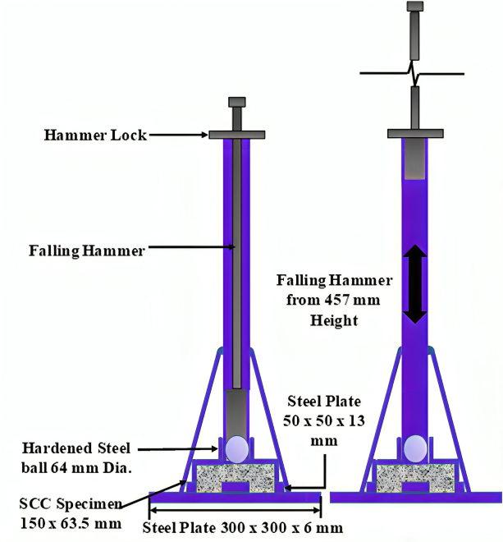
Figure 5. Schematic representation of impact strength test setup
    - Elevated temperature test
According to a literature review, four critical temperatures for concrete thermal degradation were identified: 200 ℃, 400 ℃, 600 ℃, and 800 ℃ (Ho et al., 2024; P. Zhang et al., 2023). Distinct phases of the degradation process are represented by these temperatures. Calcium hydroxide dissociates at 400 ℃, whereas hydrated compounds dehydrate at 200 ℃. Calcite dissociated at 600 ℃, and hydration products were entirely lost at 800 ℃. An electric furnace with an ultimate temperature rating of 1400 ℃ was employed to heat concrete samples (Kanagaraj et al., 2024a, 2024b) in accordance with ISO 834 (Standard and Preview, 1999) guidelines, as depicted in Figure 6. The heat source was turned off for 24 h and the temperature was maintained for 1 h before cooling. Figure 7 illustrates the heating and cooling processes.
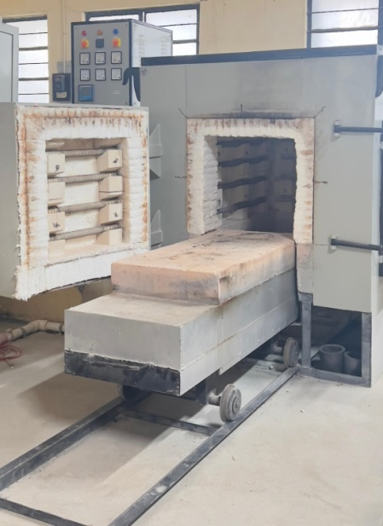
Figure 6. Electric furnace
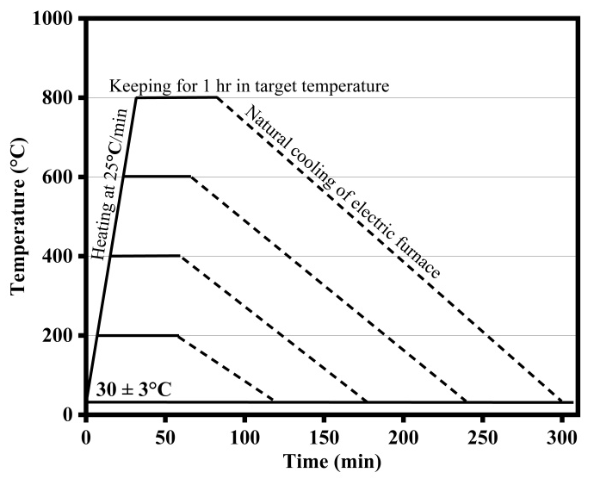
Figure 7. Heating and cooling regime
    - Weight loss, Sorptivity, and Scanning electron microscopy (SEM) Analysis
To calculate the weight loss (WL) percentage, AANC impact specimens were exposed to the temperatures of 200 ℃, 400 ℃, 600 ℃, and 800 ℃, and the WL was determined (Kanagaraj et al., 2024b). The weights before and after exposure were compared to derive the Weight Loss Factor (WLF) of AANC. Eq. (1) was used to calculate the WLF of AANC mixtures at different exposure temperatures.
$WLF (\%)=\left(\frac{M_{a}}{M_{b}}\right)×100$ (1)
Where M_{a} is the WL of the AANC mixes after heat exposure and M_{b} is the weight of the AANC mixes before heat exposure.
The capillary movement of water molecules through AANC specimens over a specific period is referred to as sorptivity. The sorptivity test was conducted in accordance with ASTM C1585-13 (2004) (“ASTM C 1585, Standard Test Method for Measurement of Rate of Absorption of Water by Hydraulic-Cement Concretes, Annu.) B. ASTM Stand. (2004). www.astm. org,” n.d.). Heated impact specimens were used to measure the sorptivity of AANC with nMs. The side surfaces of the specimens were impermeable by applying a layer of bitumen and covering it with a tape. The AANC specimens with nMs were submerged in a water container to ensure that the water level was consistently maintained with a head approximately 10 mm above the base. The initial weight of each specimen was determined under the normal environmental conditions. Subsequently, AANC specimens containing NMs were extracted from the water container at regular intervals of 5, 10, 15, 30, 60, 180, 360, 720, and 1440 min. The WA rate for the AANC with nMs was determined by applying the formula specified in Eq. (2).
$I=\left(\frac{m_{t}}{a/d}\right)$ (2)
Where I is the absorption (mm³/mm²), m_{t} is the change in mass (g), d is the density of water (kg/m³), and is the area of the specimen (mm²).
In GB mode, the SEM employed a Jeol 7610FPLUS Schottky field emission instrument from Japan, which provided resolutions of 1.1 nm at 1 kV, 1.3 nm at 1 kV, and 1 nm at 15 kV [40].
- Results and Discussion
  - Fresh properties
This study evaluated the efficacy of AANC when combined with varying proportions of NM (Figure 8). The workability of the AANC was evaluated using a slump cone test. The maximum slump was achieved with 0 % nFA and a value of 70 mm, and the minimum slump was achieved with 15 % nFA. The slump values decreased as nFA content increased. This was because of the high surface area of nFA, which contained unsaturated Si-O bonds, absorbed water from AAs, and formed Si-OH, resulting in a more rigid AANC composite. The slump values for various nGS percentages varied from 41 mm to 70 mm. The maximum decline was observed in the mixture with 0 % nGS, whereas the least was observed in the mixture with 15 % nGS. Perhaps due to the high water consumption of nBT nanoparticles and the extensive surface area of unsaturated Si-O bonds, the slump levels decreased as the nBT content increased(Ibrahim et al., 2018).
Because of the high water demand of NMs, which absorb more water during mixing, the AANC mix becomes less workable. Air entrapment can result from improper dispersion. Because of the larger surface area, higher surface energy, and smaller particle size of the NMs, the interaction rate of the structure was improved. The addition of nanoparticles (i.e., Nano silica(NS)) to GPC reduces slump values because the increased specific surface area of NS particles, when compared to binder particles, increases water demand during mixing and reduces the workability of the GPC mixture (Shahrajabian and Behfarnia, 2018). This decline in the slump value is also attributed to NS's small particle size (Nuaklong et al., 2020). Consequently, it is advisable to use superplasticizers or high-range water-reducing admixtures to provide GPC-containing nanoparticles with the required workability (Gao et al., 2015).
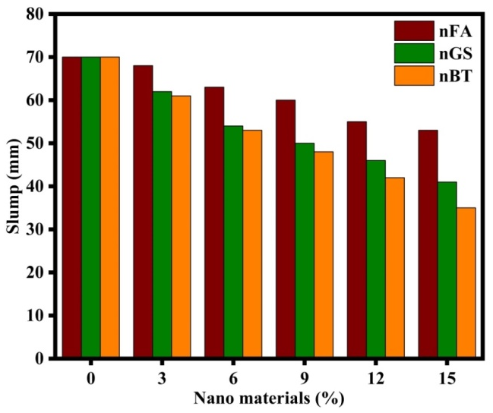
Figure 8. Slump of AANC specimens
  - Mechanical properties
    - Compressive strength
After 28 days, the strength of the AAC mixture or control mix was 40.69 MPa (Figure 9); however, the 28-day CS varied from 37.25 to 56.14 MPa when nFA was used as part of the precursor. The inclusion of varying amounts of nFA led to increases or decreases in the 28-day CS of 10.27 %, 27.32 %, 37.97 %, 18.87 %, and -8.45 % for 3 %, 6 %, 9 %, 12 %, and 15 % addition. The 28-day CS values obtained by replacing the binder with nGS ranged from 47.07 to 60.37 MPa. Incorporating 3 %, 6 %, 9 %, 12 %, and 15 % of nGS led to corresponding increase in 28-day CS of 15.67 %, 32.24 %, 42.89 %, 48.37 %, and 38.24 %, respectively. The 28-day CS values obtained by substituting nBT with the binder ranged from 42.48 to 45.24 MPa. Improved particle arrangement, higher concrete density, and void filling are some of the reasons for the improved strength development in AANC with an optimal proportion of NMs.
The early stage strength of concrete can be increased, and the polymerization process is accelerated using NMs. They can increase microstructure homogeneity and compactness, which can increase the load-bearing capability (Nuaklong et al., 2018). By interacting with AAC binders, NMs can accelerate geopolymerization. They promote continuous strength gains through the 28th day by aiding the gradual formation of a well-formed AANC matrix (Raj et al., 2023). By improving particle packing, filling voids, and increasing the overall density of concrete, NMs help accelerate the hardening process and increase the CS. A higher long-term strength is a result of better mechanical interlocking and more efficient stress transfer brought about by the enhanced microstructure (Zaid et al., 2024). Research indicates that up to a 2 % addition of NS can improve GPC CS; however, after 2.5 %, poor dispersion and agglomeration cause the rise in CS to decrease (Kotop et al., 2021). The optimal dosages of 4 % NS and 6 % nano-metakaolin increase strength by 26.31 % and 18.42 %, respectively (Rabiaa et al., 2020). However, while high concentrations of both pozzolan types initially improve CS, inadequate hydration reactions cause CS to fall after a certain threshold.
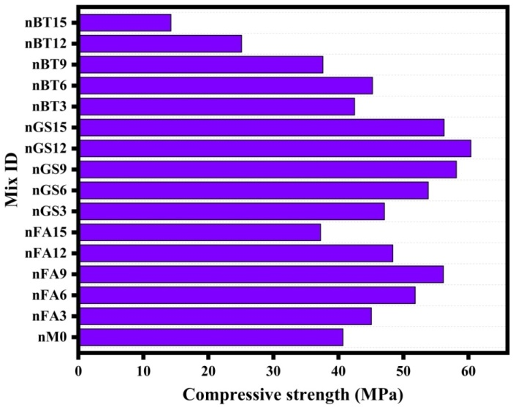
Figure 9. CS of AANC specimens
    - Rebound hammer
Rebound number is a measure of CS, which is significantly influenced by the addition of NMs. Its efficacy may be affected by elements such as the type of NMs used, proportion, distribution, curing conditions, and testing procedures. As shown in Figure 10, there was a clear trend of increasing rebound number values with different proportions and types of NMs. This indicates that AANC is gaining strength with NMs. Substituting the binder with nFA, nGS, nBT, and without NMs resulted in 28-day rebound numbers ranging from 41 to 50, 46 to 51, 25 to 45, and 42, respectively. Filling voids, particle placement, and higher concrete density are responsible for the improved strength development in AANC with an appropriate NM proportion. There was a similar rise in 28-day rebound numbers of 19.05 %, 21.43 %, and 7.14 %, respectively, when 9 % of nFA, 12 % of nGS, and 6 % of nBT were included.
NS is often added to improve mechanical properties, leading to higher rebound numbers. Proper dispersion enhances the bonding between the particles and AAC matrix. Curing conditions, such as temperature and humidity, also affect strength development. The surface roughness, moisture content, and defects can also affect the rebound number (Faleschini et al., 2022; Kumavat and Chandak, 2023). NMs such as NS and nano alumina can enhance the packing density of particles in concrete, leading to an increased density and higher CS. This resulted in higher RH values. NS accelerates the pozzolanic reaction, forming additional binding phases and denser microstructures. NMs also reduce porosity and permeability and improve resistance to moisture ingress and chemical attacks. They also influence the setting time and curing process of AAC, thereby improving the hydration kinetics and overall mechanical properties. The dosage of NMs added to AAC significantly affects its mechanical properties and RH number (Kumavat et al., 2021).
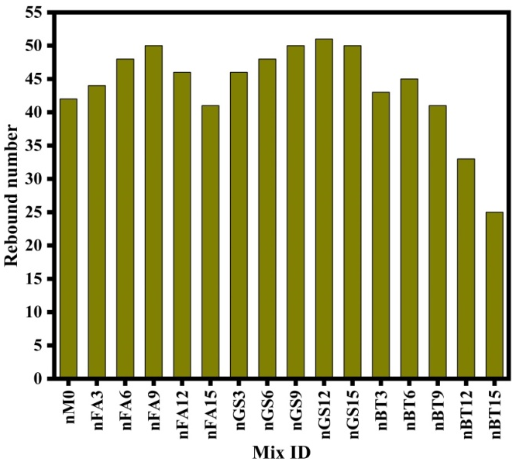
Figure 10. Rebound number of AANC specimens
    - Impact strength
The impact strength of AANC can be influenced by the addition of NMs. These NMs can improve particle packing, interfacial transition zone, FS, reduce micro cracks and porosity, and enhance toughness. They can enhance the packing density of particles, improve load transfer, and enhance the bond between the AAC binder and aggregate. Additionally, NMs can reduce micro crack formation, decrease porosity, and improve energy absorption and dissipation during impact events. Particle size and distribution, as well as the type of nanomaterial, may all affect the strength of the influence of NM on AANC.
Figure 11 show that all NM-incorporated mixes retained higher impact strength than the standard matrix. To examine the sole impact of the incorporation of NMs on the impact strength, the strengths of AAC without NMs were compared. As shown in Figure 11(a), addition of 9 % of nFA, 12 % of nGS, and 6 % of nBT increased the cracking impact number as well as the failure impact number. When compared with the control specimen, the percentage increase in cracking impact number for nFA9 %, nGS12 %, and nBT6 % specimens was approximately 92.39 %, 173.91 %, and 40.22 %, whereas the failure impact numbers were approximately 91.86 %, 144.72 %, and 29.27 %, respectively. In general, the cracking impact resistance and failure impact resistance improved up to the optimal dosage of the NMs, beyond which the impact resistance declined gradually, as illustrated in Figure 11(b).
According to earlier research(G Murali et al., 2021; Gunasekaran Murali et al., 2021), 0.2 % of MWCNT may greatly increase impact strength, leading to up to a 23 % increase in fracture resistance and a 66 % increase in failure resistance. This shows that MWCNTs can increase the resilience of preplaced two-stage concrete to impact. Variations in the aggregates utilized in the research may account for the discrepancies in the percentage increases in the impact estimates. MWCNTs function as nanoscale reinforcements in the cement matrix, altering the progression of fractures into microcracks and prolonging the initial appearance of the cracks.
With fewer micro voids and the pozzolanic reaction is facilitated by nano-alumina particles, which also improves the mechanical properties of the microstructure (Paruthi et al., 2023). This leads to better load transfer and increased resistance to impact-induced cracking. CNTs acted as reinforcements, enhancing the tensile strength and toughness of AAC. They bridge micro cracks and inhibit crack propagation, thereby improving the resistance to impact-induced damage. Nano clay particles act as nano fillers, improving the packing density and reducing porosity. However, the specific effects may vary depending on factors such as the nanomaterial type, concentration, and dispersion (Paruthi et al., 2023; Zaid et al., 2024). Experimental investigation and optimization are typically required to determine the most effective combination of NMs to enhance AAC's impact strength of AAC.
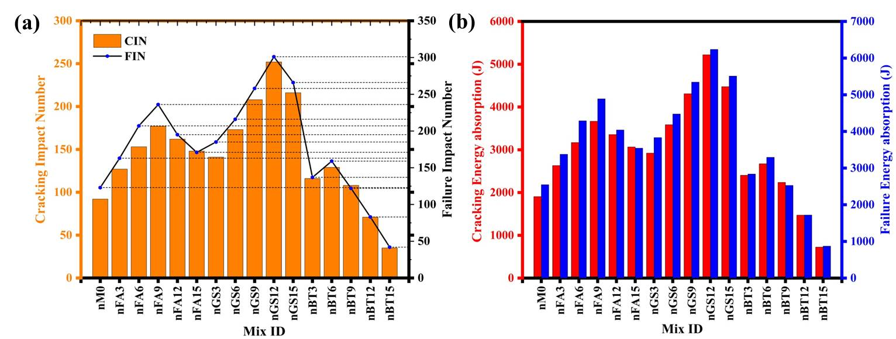
Figure 11. (a) Impact number of AANC specimens; (b) Energy absorption of AANC specimens
  - Residual properties
    - Residual impact energy
The residual impact strength of AAC with NMs upon exposure to high temperatures depends on a number of variables, including the type and proportion of NMs, curing circumstances, exposure temperature, and duration. Figure 12 (a–c) show the pre-heated, heated, and post-heated specimens. The impact energy at failure and the associated number of blows for the AANC samples combined with nFA, nGS, and nBT exposed to high temperatures are shown in Figure 13(a-f). The AANC specimens that were not treated with heat, such as nFA, nGS, and nBT, exhibited greater impact energy levels than the heated samples.
For the standard specimens, the impact energies were 4888 J, 6235 J, and 3293 J, respectively, for the nFA9 %, nGS12 %, and nBT6 % specimens. After attaining the target temperature, the specimens were maintained at that temperature for one hour. The failure impact energy for the nFA9 % (no. of blows: 239), nGS12 % (no. of blows: 313), and nBT6 % (no. of blows: 171) was determined to be 4950 J, 6483 J, and 3542 J, respectively, at 0.35 min (to obtain 200℃) and 1 hour of heating duration. As the heating period increased to 1.68 minutes (to achieve 400℃) and 1 h, the failure impact energy increased to 5075 J, 6794 J, and 3728 J for the nFA9 % (no. of blows: 245), nGS12 % (no. of blows: 328), and nBT6 % (no. of blows: 180), respectively. After 6.748 min (to attain 600 ℃) and 1 h of heating, the failure impact energy decreased to 3252 J, 4329 J, and 1885 J for the nFA9 % (no. of blows: 157), nGS12 % (no. of blows: 209), and nBT6 % (no. of blows: 91). The failure impact energy for the nFA9 % (no. of blows: 81), nGS12 % (no. of blows: 119), and nBT6 % (no. of blows: 49) decreased significantly to 1677 J, 2465 J, and 1015 J, respectively, as the duration was further extended to 25.998 min (to achieve 800 ℃) for 1 h. The percentage losses in impact energy after being exposure to 800 ℃ for nFA9 %, nGS12 %, and nBT6 % specimens were 65.68 %, 60.47 %, and 69.18 %, whereas the control specimen showed a loss percentage of 82.93 %. When the temperature contact crossed 800℃, the impact energy of all samples exhibited a sharp decrease. Nevertheless, the specimens that were supplemented with NMs may effectively resist temperature penetration and experience a reduced energy loss even after to 800 ℃ temperature exposure.
To enhance the durability and mechanical characteristics of concrete, NMs, such as silica nanoparticles, CNTs, and graphene oxide, are used. Nevertheless, their efficacy is contingent on specific applications and circumstances. Incorporating NMs into AANC can improve the thermal degradation resistance, retain mechanical properties such as impact strength, and mitigate heat-induced microstructural changes (Paruthi et al., 2023). Additionally, NMs can influence the microstructure of AANC, potentially improving the interfacial bonding and overall performance. While NMs have the potential to enhance AANC performance, further research and testing are needed to fully understand their effects and optimize their use in practical applications (P. Zhang et al., 2023).
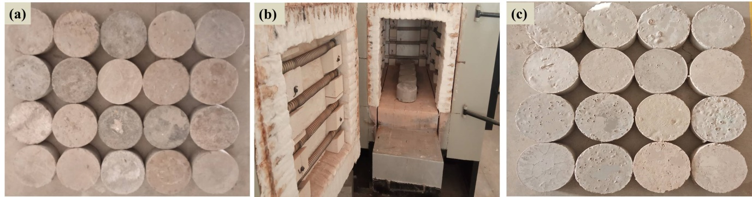
Figure 12. (a) Pre-heated specimens; (b) Heating of AANC specimens; (c) Post-heated specimens

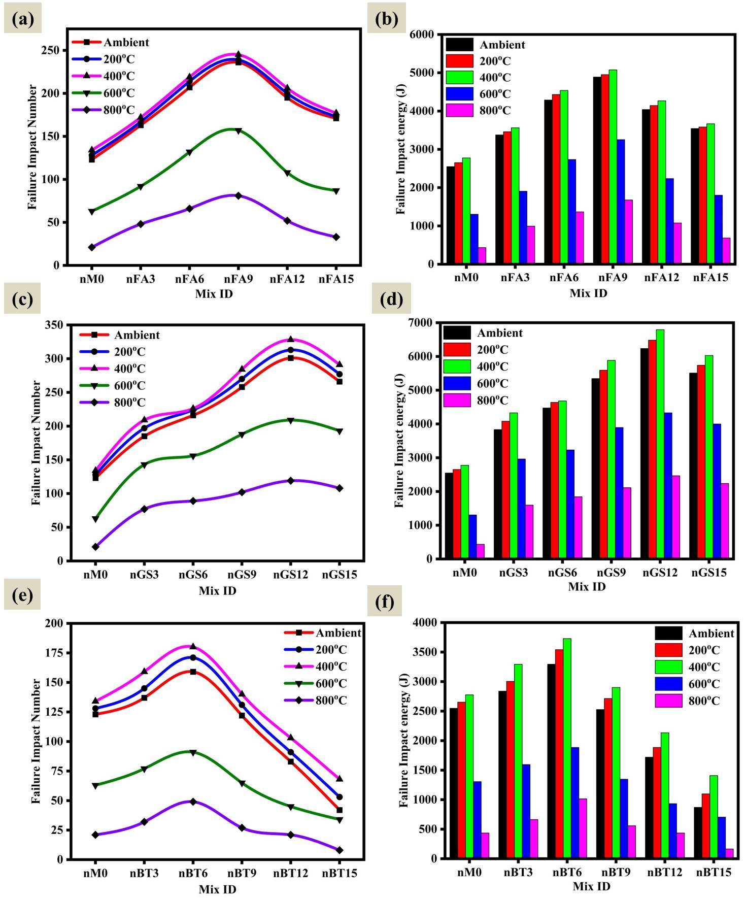
Figure 13. (a) Residual impact number of nFA specimens; (b) residual impact energy of nFA; (c) residual impact number of nGS specimens; (d) residual impact energy of nGS; (e) residual impact number of nBT specimens; (f) residual impact energy of nBT

    - Weight loss
Numerous variables, such as the concentration and type of NMs, the composition of the AAC mix, the duration and intensity of the exposure, and the testing conditions, affect the WL of AAC specimens. Different types of NMs can affect the resistance of concrete to high temperatures, and the concentration of NMs can also influence their behavior under heat. The composition of the AAC mix, including alkali activators, precursors, aggregates, and other additives, can also affect the response of concrete to elevated temperatures (Kanagaraj et al., 2024b, 2024a). Longer exposure to higher temperatures typically results in greater WL owing to dehydration, chemical decomposition, and other thermal effects. The cooling method, such as ambient cooling, can also affect the results. To accurately determine the WL of AAC specimens with NMs after exposure to elevated temperatures, laboratory experiments under controlled conditions were conducted to isolate individual effects and understand the specific behavior under thermal stress (Yu et al., 2024a; P. Zhang et al., 2023).
For all AANC specimens that were subjected to temperatures exceeding 200 ℃, 400 ℃, 600 ℃, and 800 ℃, the WL was measured. The mass loss for both the control and AANC samples decreased when the specimens were heated up from room temperature to 200, 400, 600, and 800 ℃, as shown in Figure 7. When NMs are incorporated into AAC, the mass loss is substantially decreased when it is subjected to heat. The samples exhibited minimal weight reduction at ambient temperature, which may be related to the evaporation of the free water stored inside the samples. Before and soon after exposure to elevated temperatures, the nFA, nGS, and nBT-blended AAC samples were weighed, and the WL percentage was determined by calculating the average WL. After exposure to elevated temperatures ranging from 200 ℃ to 800 ℃ the AANC samples cooled by their own and the WL was calculated is illustrated in Figure 14 (a-c). The WL increased as the contact temperature increased, as shown in Figure 14.
The nFA-added samples exhibited lower WA than the nGS- and nBT-added specimens. FA is primarily composed of silica, alumina, and iron oxide, which are not as hydrophilic (water-attracting) as the minerals found in GGBFS and BT. BT contains minerals, such as montmorillonite, which has a high affinity for water molecules, leading to a higher WA. The WL rose to 200 ℃ as a result of the vaporization of pore water and the partial dehydration of chemically bound moisture content in the matrix. In addition, WL was caused by the dehydroxylation of OH groups and dehydration of the polymer gel. At 200 ℃, the WL of AANC with 3, 6, 9, 12, and 15 percent nFA mix were found to be 2.06 %, 1.99 %, 1.77 %, 1.88 %, and 1.99 %; AANC with 3, 6, 9, 12, and 15percent nGS mix were found to be 2.34 %, 2.23 %, 2.01 %, 1.97 %, and 2.12 %; and AANC with 3, 6, 9, 12, and 15 percent nBT mix were found to be 2.67 %, 2.25 %, 2.35 %, 2.46 %, and 2.69 %. Whereas 800 ℃, the WL of AANC with 3, 6, 9, 12, and 15 percent nFA mix were found to be 3.52 %, 3.40 %, 3.29 %, 3.30 %, and 3.49 %; AANC with 3, 6, 9, 12, and 15 percent nGS mix were found to be 3.83 %, 3.70 %, 3.58 %, 3.41 %, and 3.69 %; and AANC with 3, 6, 9, 12, and 15 percent nBT mix were found to be 4.27 %, 3.91 %, 3.97 %, 4.03 %, and 4.29 %. Moreover, the nGS and nBT mixes possessed a higher WL percentage than the nFA mix.
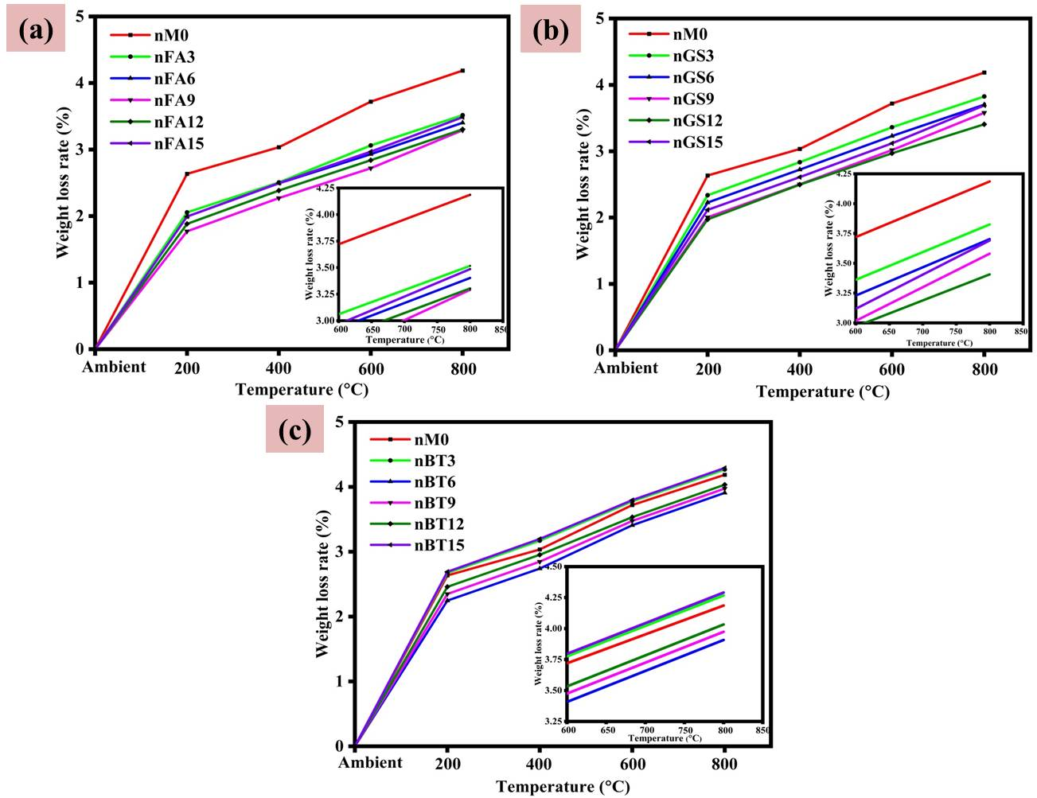
Figure 14. WL of AANC specimens with (a) nFA; (b) nGS; (c) nBT
    - Failure crack analysis
Cracking of AAC specimens with NMs can occur because of factors such as thermal expansion, thermal gradients, and changes in material properties. Different concrete components, such as aggregates, binders, and NMs, have different coefficients of thermal expansion, leading to internal stresses and cracking. Heating can induce moisture evaporation and increase the pore pressure, which can cause microcracks to form and propagate. Certain components may undergo phase transformations or decomposition at elevated temperatures, leading to volume changes, internal stresses, and cracking (Yu et al., 2024a; P. Zhang et al., 2023). The presence of NMs can influence the crack initiation and propagation behavior. Effective dispersion and bonding of NMs can enhance their resistance to crack formation, while agglomeration or inadequate dispersion may exacerbate cracking. Elevated temperatures can accelerate chemical reactions, leading to binder degradation and weakening, reducing the overall strength of concrete and increasing its susceptibility to cracking (Paruthi et al., 2023; Zaid et al., 2024).
The failure patterns of the AAC samples and AAC blended with NMs (nFA, nGS and nBT) subjected to elevated temperatures are shown in Figure 15. Line crack failure occurred in all samples following exposure to a 200 ℃ heating process. The samples exhibited sudden and apparent failure, followed by the occurrence of line cracks. Consequently, they are divided into multiple parts along the line crack. The nFA samples exhibited smaller line crack widths than the other samples. For the 400 ℃ exposure condition, an identical pattern was noticed. Only the crack width observed in the nBT specimens was larger than those in the other specimens.
The failure pattern exhibited substantial differences when the exposure heat exceeded 400℃ and 600 ℃ of heat. At such temperatures, the influence of the NMs was evident. In the samples with no NMs and those with nBT incorporated, significant exterior micro cracks were detected. During the heating and loading phases, the samples ultimately failed owing to the occurrence of multiline fractures. The samples ultimately fractured into multiple pieces as multiline cracks appeared across the fracture zone. Conversely, the samples supplemented with nGS lacked thermal micro cracks on their surfaces. These samples maintained their ability to absorb impact energy and resist impact pressure even after the initial fracture emerged. The samples exhibited a mixture of spalling and fracture failure at 800 ℃ of exposure. Critical exterior cracks appeared in all samples after being exposure to 800 ℃. The ultimate failure pattern was curved, and significant surface cracks initiated along the fracture zone, resulting in curved zigzag rupture failure. The control specimens developed multiple crack lines and failed. The most significant failure pattern was observed after the 800 ℃ exposure. It was noted that the addition of the NMs was effective only up to the 400 ℃ exposure; beyond that, there was a decline in the impact energy. In addition, the ultimate failure of the samples was the result of a mixture of curved and line cracks that originated from the fracture zone, regardless of the incorporation of NMs (Kanagaraj et al., 2024b).
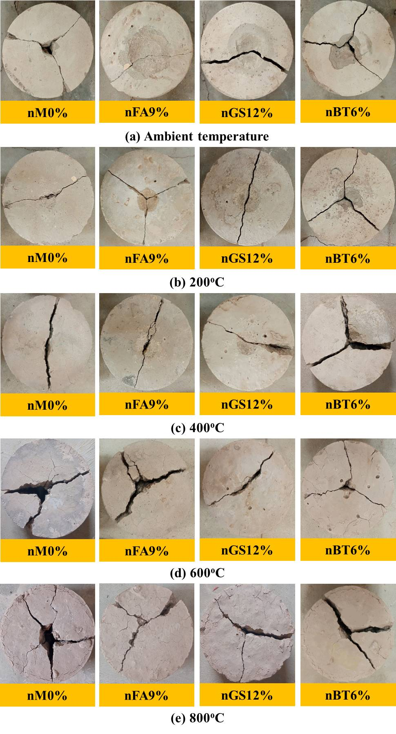
Figure 15. Crack pattern/ Failure mode of AANC impact specimens exposed to (a) Ambient temperature; (b) 200 ℃; (c) 400 ℃; (d) 600 ℃; (e) 800 ℃
    - Spalling properties
When concrete structures are exposed to fire or high temperatures, a phenomenon known as spalling occurs, which involves the separation of layers of concrete from the main structure, often in the form of chips or flakes. In AAC containing NMs, spalling can occur owing to various factors. Elevated temperatures lead to the evaporation of moisture trapped within the pores of concrete, creating internal pressure and micro cracks near the surface. The shrinkage of concrete and accumulation of trapped pore-water pressure are the main reasons for spalling caused by temperature or fire. Cracks that cause spalling result from the evaporation of chemically bonded and freely available water, which causes shrinkage. Additionally, explosive spalling, another form of spalling, occurs when water pressure is unable to escape from the dense structure, leading to the rapid and forceful separation of concrete layers (Kanagaraj et al., 2024b; Nuruddin et al., 2014).
The inclusion of NMs in concrete can alter its thermal characteristics and response to high temperatures. If NMs are not properly dispersed, they clump together, which can worsen the concentration of thermal stress and increase the likelihood of spalling. Elevated temperatures may prompt chemical reactions in the AAC matrix or cause changes in its constituent materials, resulting in expansion or contraction, internal tension, and surface fissures. Exposure to high temperatures can accelerate the deterioration of AANC, diminishing their structural strength (Zaid et al., 2024). Cracks and dangerous spalling in concrete result from an increase in pore water pressure. The compact and dense inner arrangement of concrete with superior strength produces substantial internal pressure, rendering it particularly prone to spalling. In addition, the interior and exterior surfaces of the sample may experience differences in heat dispersion, which can result in spalling. A stronger heat difference is a consequence of enhanced contact with elevated temperatures, which is fueled by a greater capacity for heat and lower conductivity. Subsequently, thermal stresses appear and combine with the interior pore water pressure, giving rise to spalling. Experiments have shown no instances of spalling in any of the AANC samples (Raj et al., 2023; Zhang et al., 2020).
    - Capillary water absorption
The exposure of AAC specimens with NMs to elevated temperatures can influence capillary water absorption or sorptivity, which refers to the ability of concrete to absorb water under capillary action. The capillary water absorption and sorptivity of the nFA-AANC, nGS-AANC, and nBT-AANC mixes exposed to elevated temperatures are shown in Figure 16. The nBT6 % mix exposed to 800 ℃ shows the maximum capillary water absorption, whereas it is minimum for nGS12 % mix under ambient curing conditions. The incorporation of NMs, such as nFA, nGS, and nBT, in AANC enables a more compact and denser microstructure. This could be attributed to the filling of the internal pores by polymerization reaction products. NMs typically have high surface-area-to-volume ratios. Incorporating them into a concrete mixture exposes more reactive surfaces, which can lead to enhanced pozzolanic reactions and the formation of additional hydration products. These products contribute to a denser matrix with reduced porosity, and consequently, lower sorptivity. The capillary water absorption increased with increasing temperature exposure, as shown in Figure 16.
The capillary water absorption of the control mix was found to be approximately 96 mm³/mm² after 24 h, which was lower than that of the AANC with nBT6 %, which absorbed approximately 99 mm³/mm² under ambient curing conditions. The capillary water absorption action was enhanced for every sample when the AANC was exposed to the heating temperature. Elevated temperatures can alter the pore structure and surface properties of concrete by causing moisture evaporation, pore expansion, and changes in material composition. High temperatures may induce micro cracking and thermal expansion, leading to the creation of additional pathways for WA. Thermal stresses and phase changes can affect the connectivity and distribution of pores within the concrete matrix, thereby influencing the rate and extent of WA (Kanagaraj et al., 2024b; P. Zhang et al., 2023). When properly dispersed and incorporated into the AAC matrix, NMs can modify their microstructures and properties. The overall porosity of the matrix may be reduced, and its permeability to WA may be increased by the filling of cavities or pores with NMs. Surface modification or functionalization of NMs can enhance their interaction with the surrounding matrix, thereby improving the durability and water resistance of concrete (Meftah and Arabi, 2024; Zaid et al., 2024).
After exposure to a temperature of 400 ℃, the capillary water absorption for AANC containing 9 % of nFA was almost found to the same as that of AANC containing 12 % of nGS, whose absorption values were 110 mm³/mm² and 107 mm³/mm² respectively. The AANC mix with 6 % of nBT mix exhibited higher absorption value than that of the control mix, is approximately 121 mm³/mm². At 800 ℃, the capillary water absorption of AANC specimens was more significant than at other lower temperature ranges (i.e., ambient, 200 ℃, 400 ℃, and 600 ℃) which is due to the samples experienced extensive damage. This contributes to the creation of a greater amount of porosity within the heated concrete. The capillary water absorption rate of the nBT specimens (141 mm³/mm²) was higher than that of the control mixture (135 mm³/mm²). The absorption of capillary water is influenced by the combined presence of NMs and elevated temperature, which in turn is influenced by the type and concentration of NMs, distribution, and creation of the geopolymer gel. Elevated temperatures may alter the surface chemistry and reactivity of NMs, thereby affecting their ability to mitigate WA. NMs with hydrophobic properties or surface treatments designed to repel water may help to reduce capillary absorption, particularly in high-temperature environments. Fernandes et al. (Fernandes, B., Khodeir, M., Perlot, 2023) observed a comparable trend, attributing this phenomenon mainly to higher porosity, leading to an increase in capillary water absorption.
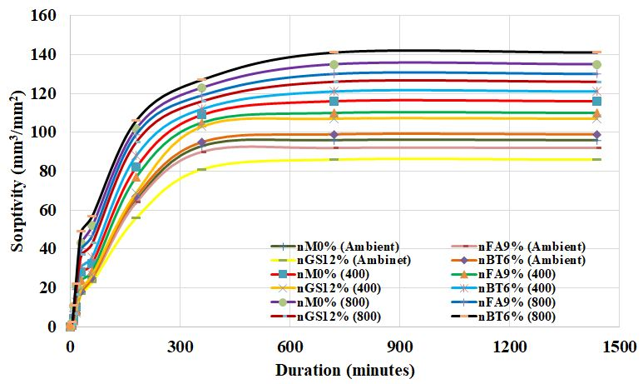
Figure 16. Sorptivity of AANC specimens with NMs exposed to elevated temperature
    - Microstructural analysis
The SEM images of AANC samples before and after being exposure to elevated temperatures of 200 ℃, 400 ℃, 600 ℃, and 800 ℃ for 1 h are depicted in Figure 17. Based on these findings, the dehydration of AAC paste at elevated temperatures is responsible for the alteration in the microstructure, particularly the phase degradation and micro cracks. The SEM images of all the AANC samples were captured at a magnification of 10,000 ×. The SEM images of the unheated AANC samples demonstrate a thick matrix that underwent the formation of an amorphous calcium silicate hydrate (C-S-H)/calcium aluminosilicate hydrate (C-A-S-H) gel during the hydration process. AANC-nFA, AANC-nGS, and AANC-nBT contained these gels in all four varieties of samples. The AANC-nFA and AANC-nGS specimens had a large quantity of C-S-H/C-A-S-H gels at ambient temperatures compared to the standard samples and AANC-nBT. The aluminosilicate characteristic of FA resulted in increased quantities of C-A-S-H/C-S-H gels in the nFA-incorporated AANC, whereas the pozzolanic reactivity of the nGS-added AANC improved the strength and durability of the AAC.
The microstructure of the AANC samples did not undergo noticeable modifications at 200 ℃, suggesting that the thermal exposure did not produce significant changes in the microstructure at this level of temperature exposure. In contrast, the AANC samples developed a denser microstructure as a result of the persistent production of the C-S-H/C-A-S-H gel within the AANC mixture. Elevated temperatures promote polymerization reactions between alkaline activators and precursor materials such as FA, GGBFS, or other aluminosilicate sources. This results in the production of supplementary C-S-H and C-A-S-H gel structures. These gel phases contributed to the densification of the microstructure. In addition, some amorphous phases present in the original microstructure of the AANC composite may crystallize or undergo phase transformations under heat treatment. The densification of the material and development of denser forms can be facilitated by such modifications. The SEM images demonstrate the formation of C-S-H, C-A-S-H gels, and zeolites, corresponding to the hydration products of AANC, at 200 ℃ and 400 ℃. These gels form as a result of the reaction between the alkaline activators and the amorphous or pozzolanic components in the materials and at elevated temperatures and can form secondary hydration products. Zeolites are crystalline hydrated aluminosilicate minerals that contribute to the strength and durability of materials. Calcium hydroxide (portlandite) can also be present as a byproduct of the alkali activation reaction, but its presence diminishes with increasing temperature owing to dehydration (Pang et al., 2022).
The microstructure of the AANC samples underwent substantial modifications when heated to 600 ℃, which included the existence of deformed C-A-S-H and C-S-H gels. The hydrated phases of the AANC samples underwent extensive dehydration at a temperature of 600 °C. The structural hydration from the C-A-S-H and C-S-H gels was lost because of this depletion. Furthermore, calcium-silicate bonds may undergo degradation at elevated temperatures, which may result in the breakdown of such gel forms. The thermal expansion coefficients of various components within the AANC specimens, including the nanoscale additives and gel phases, may differ. This discrepancy in thermal expansion rates can lead to the development of internal stresses within the material as it undergoes heating. These stresses can result in the distortion and alteration of the morphology of the C-S-H and C-A-S-H gel phases. High temperatures can cause the formation of pores within AANC specimens as gases evolve from decomposition reactions or the vaporization of water trapped within the material (Access, n.d.; Raj et al., 2023). Exposure to 800 ℃ can lead to significant structural collapse of the AANC composite owing to the decomposition and weakening of the gel phases and other components. As illustrated in Figure 17 (e), this can lead to the formation of cavities and holes within the material, thereby diminishing its density and strength. The AANC composite may experience a substantial reduction in mechanical characteristics as a consequence of the structural collapse, extensive decomposition, and development of porosity at 800 ℃.
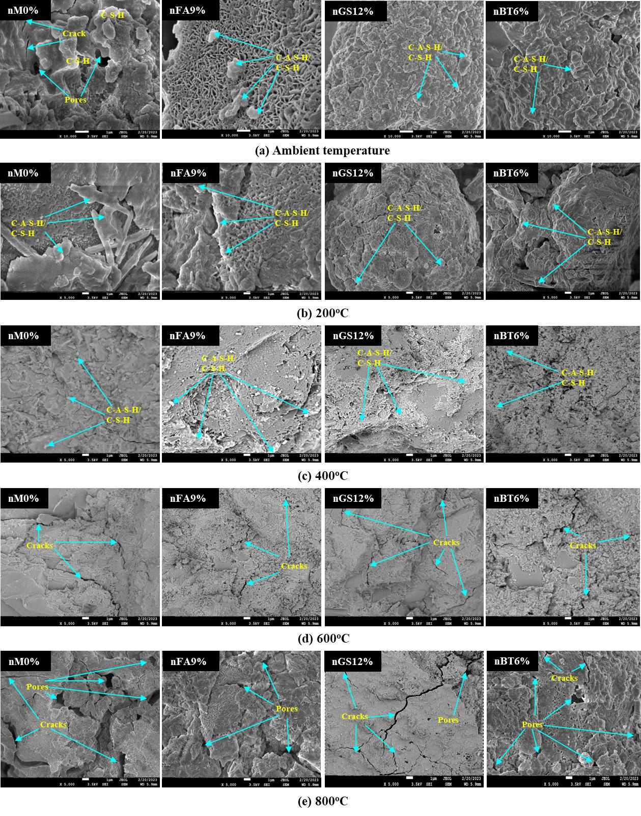
Figure 17. SEM images of AANC specimens exposed to (a) Ambient temperature; (b) 200 ℃; (c) 400 ℃; (d) 600 ℃; (e) 800 ℃
- Prediction of Impact energy and residual impact energy
  - Analytical modelling
The impact and residual impact energies from the acquired experimental findings must be determined to create a prediction model. Plotting the experimental vs. theoretical curves is shown in Figures 18 and 19, where it is evident that the theoretical curve fits the experimental data effectively, with R² within 0.91 and 0.95. These equations were used to predict the impact energy from the RH number and to predict the residual impact energy from the 28th day of CS.
Table 3. Analytical model for AANC
Predicated Impact energy details | Predicted model | R²
28th-day Impact energy | $$I=152.8e^{0.0705RH}$$ | (R² = 0.940)
For 200 ℃ exposure | $$R=718.86e^{{0.0356f}_{c}}$$ | (R² = 0.954)
For 400 ℃ exposure | $$R=903.72e^{{0.0319f}_{c}}$$ | (R² = 0.949)
For 600 ℃ exposure | $$R=325.09e^{{0.0416f}_{c}}$$ | (R² = 0.919)
For 800 ℃ exposure | $$R=73.759e^{{0.0574f}_{c}}$$ | (R² = 0.912)

Where I = Impact energy, RH = Rebound number, R = residual impact energy, and f_{c} = 28th day CS of concrete.
Table 3 lists the predicted models and their R² values. Figures 18 and 19 show the actual and anticipated results, respectively, compared with the suggested models to simplify the analysis. It is evident from the findings that the practical values closely matched the results predicted by the created model. Thus, Figure 18 and 19 show that the predicted models in Table 3 are effective in predicting the impact energy at 28 days and the residual impact energy of the AANC at different temperatures.
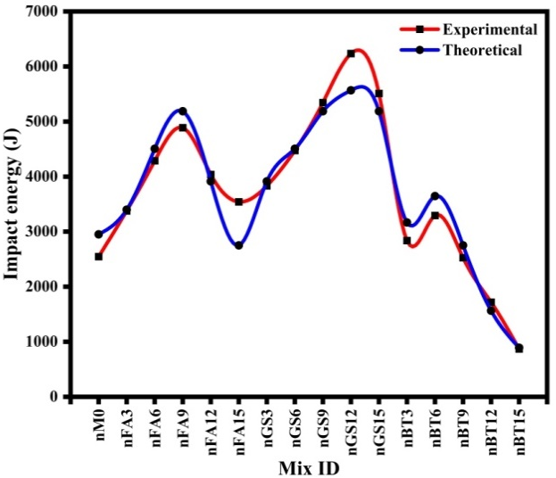
Figure 18. Experimental vs analytical impact energy of AANC
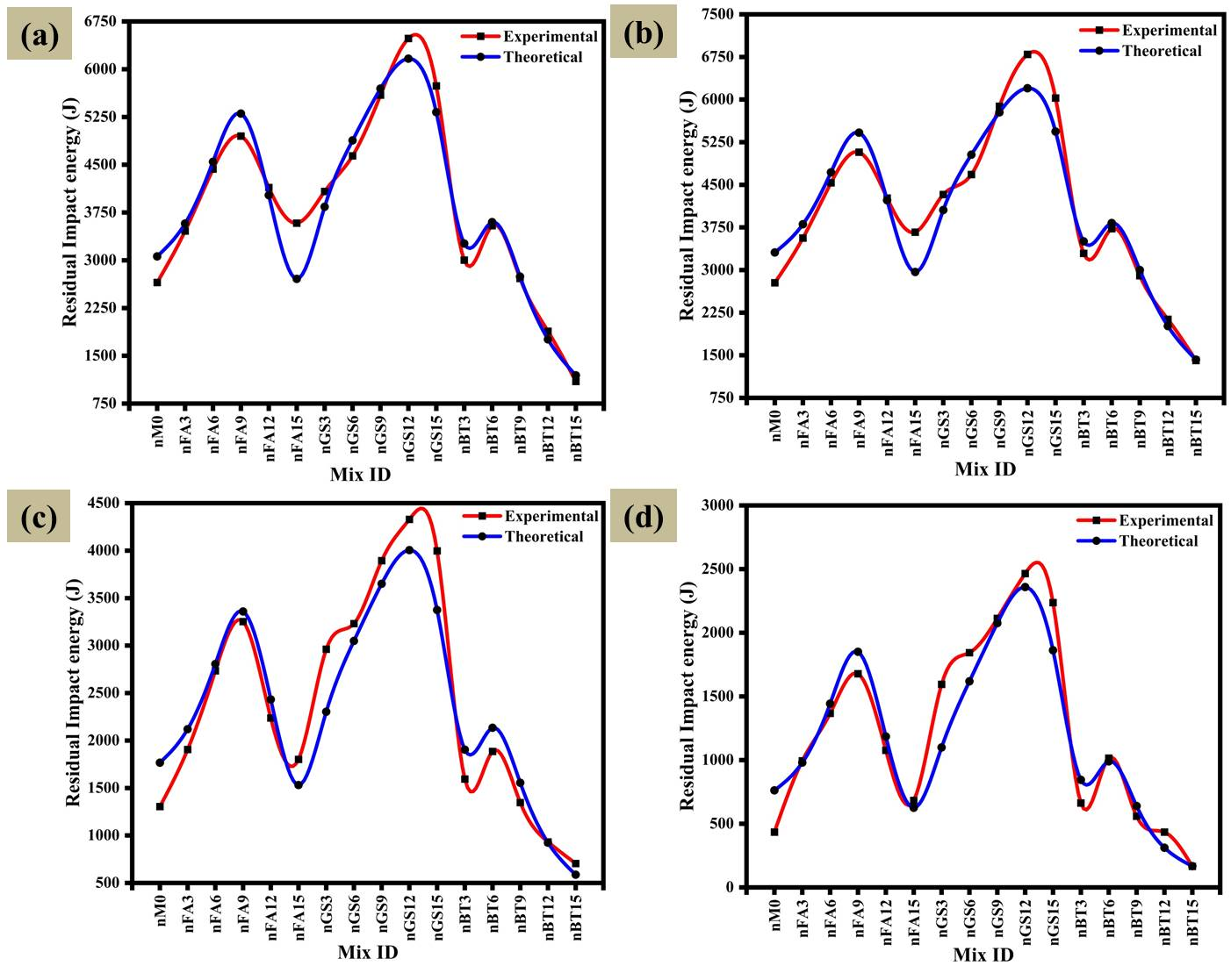
Figure 19. Experimental vs analytical residual impact energy of AANC specimens exposed to (a) 200 ℃; (b) 400 ℃; (c) 600 ℃; (d) 800 ℃
- Conclusions
The influence of exposure to elevated temperatures and the impact resistance of AANC composites with different NMs were investigated in this study. This study investigated the effects of temperature exposure on the decrease in impact energy, weight loss, failure crack pattern, spalling characteristics, and capillary water absorption of ambient-cured AANC specimens. The SEM images provided insight into the impact of temperature. The impact and residual impact energies were predicted using regression models.
- The addition of NMs such as nFA, nGS, and nBT significantly influenced the workability, CS, and rebound number of the AANC. The variations in the slump values are attributed to factors such as WA and particle size. The CS of AANC was improved with the incorporation of these NMs, ranging from 37.25 to 60.37 MPa at 28 days, owing to void filling and increased concrete density. The rebound number also increased with different proportions of NMs, indicating strength enhancement, which was attributed to factors such as void filling and particle arrangement.
- Compared to the control specimen, the percentage increases in cracking impact numbers for nFA9 %, nGS12 %, and nBT6 % specimens were 92.39 %, 173.91 %, and 40.22 %, respectively, while the increases in failure impact numbers were 91.86 %, 144.72 %, and 29.27 %, respectively. Generally, Cracking and failure impact resistance improved up to the optimal dosage of NMs, but declined beyond this point.
- The AANC specimens incorporated with nFA, nGS, and nBT exhibited higher impact energy levels than the control specimens. For standard samples, the impact energies were 4888 J, 6235 J, and 3293 J for nFA9 %, nGS12 %, and nBT6 %, respectively. The breakdown impact energy declined to 1677 J, 2465 J, and 1015 J for the nFA9 %, nGS12 %, and nBT6 % specimens, respectively, after exposure to 800 °C. In comparison with the standard sample, the energy reductions were 65.68 %, 60.47 %, and 69.18%.
- The examination of AANC specimen weight loss was examined at high temperatures, varying between 200 °C and 800 °C. The incorporation of NMs significantly increased the mass loss compared to the control samples, especially in the nGS and nBT mixes because of their hydrophilic nature. All specimens showed line crack failures after exposure to 200 °C and 400 °C, with nFA specimens having smaller cracks. At 600 °C, critical surface micro cracks appeared in specimens without NMs and those with nBT, but nGS specimens remained intact. At 800 °C, all specimens exhibited cracking failure, yet no AANC samples experienced spalling, indicating their resilience to elevated temperatures.
- Capillary water absorption, with higher absorption rates for nanomaterial-added specimens compared to the control specimens when exposed to high temperatures. Additionally, SEM images revealed significant changes in the microstructure, including micro-cracks, due to dehydration of the alkali-activated composite under high temperatures, leading to decreased mechanical properties.
- The impact energy and residual impact energy for the three groups of AANC after temperature exposure were analyzed to develop a predictive model. The experimental and theoretical curves showed good agreement, with R² values ranging from 0.91 and 0.95.

Acknowledgment
No funding was adopted to carry out the research

References
Abid, S.R., Abdul-hussein, M.L., Ayoob, N.S., Ali, S.H., Kadhum, A.L., 2020. Heliyon Repeated drop-weight impact tests on self-compacting concrete reinforced with micro-steel fi ber. Heliyon 6, e03198. https://doi.org/10.1016/j.heliyon.2020.e03198
Access, O., n.d. Mechanical Behavior of High-Performance Concrete under Thermal Effect 0–21.
Arockiasamy, M., Craig, R.J., Criswell, M.E., Galinat, M.A., Gopalaratnam, V.S., Hassoun, M.N., Hyduk, N.M., Johnston, C.D., Mitchell, N.C., Molloy, H.J., Paul, S.L., Pearlman, S.L., Robinson, R.C., 1999. Measurement of Properties of Fiber Reinforced Concrete 89, 1–12.
ASTM C989/C989M − 22, 2005. Standard Specification for Slag Cement for Use in Concrete and Mortars, ASTM International, 1-4
ASTM C33, 2010. Method for Standard Specification for Concrete Aggregates, ASTM International, 1-11. doi: 10.1520/C0033-03.
ASTM C 143, 2014. Standard Test Method for Slump of Hydraulic-Cement Concrete. Annu. B. ASTM Stand. https://doi.org/10.1520/C0143., n.d.
ASTM C 1585, Standard Test Method for Measurement of Rate of Absorption of Water by Hydraulic-Cement Concretes, Annu. B. ASTM Stand. (2004). www.astm. org, n.d.
ASTM C618–12a, Standard Specification for Coal Fly Ash and Raw or Calcined Natural Pozzolan for Use in Concrete, ASTM International, West Conshohocken, PA, www.astm.org, ASTM Int. 2014, 2012. 1–5. https://doi.org/https://doi.org/10.1520/C0618.
Azar, P., Samson, G., Cussigh, F., Frouin, L., Idir, R., Cyr, M., 2024. Durability of sodium carbonate alkali-activated slag concrete assessed by a performance-based approach 423. https://doi.org/10.1016/j.conbuildmat.2024.135873
Bezemer, H.J., Awasthy, N., Lukovi, M., 2023. Multiscale analysis of long-term mechanical and durability behaviour of two alkali-activated slag-based types of concrete 407. https://doi.org/10.1016/j.conbuildmat.2023.133507
Cost, R., Hughes, S., Cvetic, P., Newby, R., Homsy, S., Zoelle, A., Woods, M., Grol, E., Fout, T., 2024. Carbon Capture Science & Technology The Impact of Cement Plant Air Ingress on Membrane-Based CO 2 Capture United States Department of Energy. Carbon Capture Sci. Technol. 11, 100201. https://doi.org/10.1016/j.ccst.2024.100201
Dahlan, A.S., 2021. Impact of nanotechnology on high performance cement and concrete. J. Mol. Struct. 1223, 128896. https://doi.org/10.1016/j.molstruc.2020.128896
Drilled, T., Statements, B., 2009. Standard Test Method for Rebound Number of Hardened Concrete 1 8–10.
Faleschini, F., Espinosa, A.B., Revilla-cuesta, V., Ortega-l, V., Serrano-l, R., 2022. Hammer rebound index as an overall-mechanical-quality indicator of self-compacting concrete containing recycled concrete aggregate 347. https://doi.org/10.1016/j.conbuildmat.2022.128549
Fernandes, B., Khodeir, M., Perlot, C., 2023. Durability of concrete made with recycled concrete aggregates after exposure to elevated temperatures. Mater. Struct. 25. https://doi.org/https://doi.org/10.1617/s11527-023-02111-1
Gao, X., Yu, Q.L., Brouwers, H.J.H., 2015. Characterization of alkali activated slag – fly ash blends containing nano-Silica. Constr. Build. Mater. 98, 397–406. https://doi.org/10.1016/j.conbuildmat.2015.08.086
Ho, C.M., Doh, S.I., Chin, S.C., Li, X., 2024. The effect of particle sizes of steel slag as cement replacement in high strength concrete under elevated temperatures. Constr. Build. Mater. 411, 134531. https://doi.org/10.1016/j.conbuildmat.2023.134531
Ibrahim, M., Azmi, M., Johari, M., Maslehuddin, M., Kalimur, M., 2018. Influence of nano-SiO 2 on the strength and microstructure of natural pozzolan based alkali activated concrete. Constr. Build. Mater. 173, 573–585. https://doi.org/10.1016/j.conbuildmat.2018.04.051
IS 516, Method of Tests for Strength of Concrete -specifications 2004 New Delhi, India, n.d.
Jativa, F.W., Dalton, L.E., Pourghaz, M., 2024. Gas CO 2 foaming and intermixing in portland cement paste to sequester CO 2. Cement 16, 100099. https://doi.org/10.1016/j.cement.2024.100099
Kanagaraj, B., Anand, N., R, S.R., Jerry, R., Lukose, J., Lubloy, E., 2024a. Case Studies in Construction Materials Influence of coatings on residual strength of geopolymer concrete columns subjected to fire exposure : An experimental investigation. Case Stud. Constr. Mater. 20, e02990. https://doi.org/10.1016/j.cscm.2024.e02990
Kanagaraj, B., Anand, N., R, S.R., Lubloy, E., 2024b. Behavioural studies on binary blended high strength self compacting geopolymer concrete exposed to standard fire temperature. Ain Shams Eng. J. 15, 102394. https://doi.org/10.1016/j.asej.2023.102394
Kotop, M.A., Alharbi, Y.R., Abadel, A.A., Binyahya, A.S., 2021. Engineering properties of geopolymer concrete incorporating hybrid. Ain Shams Eng. J. https://doi.org/10.1016/j.asej.2021.04.022
Kumavat, H.R., Chandak, N.R., 2023. Journal of King Saud University – Engineering Sciences Repeatability of concrete rebound hardness using comprehensive statistical analysis. J. King Saud Univ. - Eng. Sci. 35, 167–173. https://doi.org/10.1016/j.jksues.2021.02.013
Kumavat, H.R., Chandak, N.R., Patil, I.T., 2021. Case Studies in Construction Materials Factors in fl uencing the performance of rebound hammer used for non-destructive testing of concrete members : A review. Case Stud. Constr. Mater. 14, e00491. https://doi.org/10.1016/j.cscm.2021.e00491
Lich, H., Liu, J., Doh, J., Ong, D.E.L., 2024. Influence of Si / Al molar ratio and ca content on the performance of fly ash-based geopolymer incorporating waste glass and GGBFS. Constr. Build. Mater. 411, 134741. https://doi.org/10.1016/j.conbuildmat.2023.134741
Liu, S., Zhu, D., Ou, Y., Yao, Y., Shi, C., 2018. Impact response of basalt textile reinforced concrete subjected to different velocities and temperatures. Constr. Build. Mater. 175, 381–391. https://doi.org/10.1016/j.conbuildmat.2018.04.193
Meftah, H., Arabi, N., 2024. Effects of elevated temperatures ’ exposure on the properties of concrete incorporating recycled concrete aggregates. Constr. Build. Mater. 411, 134612. https://doi.org/10.1016/j.conbuildmat.2023.134612
Murali, Gunasekaran, Abid, S.R., Amran, M., Fediuk, R., Vatin, N., Karelina, M., 2021. Combined Effect of Multi-Walled Carbon Nanotubes , Steel Fibre and Glass Fibre Mesh on Novel Two-Stage Expanded Clay Aggregate Concrete against Impact Loading.
Murali, G., Abid, S.R., Ivanovich, N., Amran, M., Fediuk, R., 2022. Influence of height and weight of drop hammer on impact strength and fracture toughness of two-stage fibrous concrete comprising nano carbon tubes. Constr. Build. Mater. 349, 128782. https://doi.org/10.1016/j.conbuildmat.2022.128782
Murali, G, Abid, S.R., Karthikeyan, K., Haridharan, M.K., Amran, M., Siva, A., 2021. Low-velocity impact response of novel prepacked expanded clay aggregate fibrous concrete produced with carbon nano tube , glass fiber mesh and steel fiber. Constr. Build. Mater. 284, 122749. https://doi.org/10.1016/j.conbuildmat.2021.122749
Nuaklong, P., Jongvivatsakul, P., Pothisiri, T., Sata, V., Chindaprasirt, P., 2020. Influence of rice husk ash on mechanical properties and fire resistance of recycled aggregate high-calcium fly ash geopolymer concrete. J. Clean. Prod. 252, 119797. https://doi.org/10.1016/j.jclepro.2019.119797
Nuaklong, P., Sata, V., Wongsa, A., Srinavin, K., Chindaprasirt, P., 2018. Recycled aggregate high calcium fly ash geopolymer concrete with inclusion of OPC and nano-SiO 2. Constr. Build. Mater. 174, 244–252. https://doi.org/10.1016/j.conbuildmat.2018.04.123
Nuruddin, M.F., Azmee, N.M., Yung, C.K., 2014. Effect of fire flame exposure on ductile self-compacting concrete ( DSCC ) blended with MIRHA and fly ash. Constr. Build. Mater. 50, 388–393. https://doi.org/10.1016/j.conbuildmat.2013.09.038
Ojedokun, O.O., Mangat, P.S., 2023. Chemical composition and physico-mechanical properties of carbonated alkali activated concrete and mortar. J. Build. Eng. 71, 106480. https://doi.org/10.1016/j.jobe.2023.106480
Pang, L., Liao, S., Wang, D., An, M., 2022. Influence of steel slag fineness on the hydration of cement-steel slag composite pastes. J. Build. Eng. 57, 104866. https://doi.org/10.1016/j.jobe.2022.104866
Paruthi, S., Rahman, I., Husain, Asif, Husain, Afzal, Manea-saghin, A., Sabi, E., 2023. Developments in the Built Environment A comprehensive review of nano materials in geopolymer concrete : Impact on properties and performance. Dev. Built Environ. 16, 100287. https://doi.org/10.1016/j.dibe.2023.100287
Rabiaa, E., Mohamed, R.A.S., Sofi, W.H., Tawfik, T.A., 2020. Developing Geopolymer Concrete Properties by Using Nanomaterials and Steel Fibers 2020.
Raj, R.S., Arulraj, G.P., Anand, N., Kanagaraj, B., Lubloy, E., Naser, M.Z., 2023. Nanomaterials in geopolymer composites : A review. Dev. Built Environ. 13, 100114. https://doi.org/10.1016/j.dibe.2022.100114
Raj, S.R., Arulraj, P.G., Anand, N., Balamurali, K., Gokul, G., 2021. Influence of Various Design Parameters on Compressive Strength of Geopolymer Concrete : A Parametric Study by Taguchi Method 34, 2351–2359.
Rawat, S., Zhang, Y.X., Fanna, D.J., Lee, C.K., 2024. Development of sustainable engineered cementitious composite with enhanced compressive performance at elevated temperatures using high volume GGBFS. J. Clean. Prod. 451, 142011. https://doi.org/10.1016/j.jclepro.2024.142011
Sanchez, F., Sobolev, K., 2010. Nanotechnology in concrete – A review. Constr. Build. Mater. 24, 2060–2071. https://doi.org/10.1016/j.conbuildmat.2010.03.014
Shahrajabian, F., Behfarnia, K., 2018. The effects of nano particles on freeze and thaw resistance of alkali-activated slag concrete. Constr. Build. Mater. 176, 172–178. https://doi.org/10.1016/j.conbuildmat.2018.05.033
Shobeiri, V., Bennett, B., Xie, T., Visintin, P., 2023. Case Studies in Construction Materials Mix design optimization of concrete containing fly ash and slag for global warming potential and cost reduction. Case Stud. Constr. Mater. 18, e01832. https://doi.org/10.1016/j.cscm.2023.e01832
Standard, I., Preview, T.S., 1999. Iso 834-1 1999.
Tu, W., Zhang, M., 2023. Behaviour of alkali-activated concrete at elevated temperatures : A critical review. Cem. Concr. Compos. 138, 104961. https://doi.org/10.1016/j.cemconcomp.2023.104961
Venkati, B., Manjulavani, K., 2024. Measurement : Sensors Variation of aggregate size using sensors based on impact strength of pervious concrete. Meas. Sensors 33, 101094. https://doi.org/10.1016/j.measen.2024.101094
Wang, T., Yu, M., Lin, H., Li, D., Li, L., 2024. Experimental investigation of mechanical properties of GGBS-FA-SF blended geopolymer concrete at elevated temperatures. Fire Saf. J. 146, 104156. https://doi.org/10.1016/j.firesaf.2024.104156
Wang, W., Chouw, N., 2017. The behaviour of coconut fibre reinforced concrete ( CFRC ) under impact loading. Constr. Build. Mater. 134, 452–461. https://doi.org/10.1016/j.conbuildmat.2016.12.092
Yu, M., Lin, H., Wang, T., Shi, F., Li, D., Chi, Y., Li, L., 2023. Experimental and numerical investigation on thermal properties of alkali-activated concrete at elevated temperatures. J. Build. Eng. 74, 106924. https://doi.org/10.1016/j.jobe.2023.106924
Yu, M., Wang, T., Chi, Y., Li, D., Li, L., Shi, F., 2024a. Residual mechanical properties of GGBS-FA-SF blended geopolymer concrete after exposed to elevated temperatures. Constr. Build. Mater. 411, 134378. https://doi.org/10.1016/j.conbuildmat.2023.134378
Yu, M., Wang, T., Lin, H., Li, D., Li, L., 2024b. Experimental investigation of transient strains of GGBS-FA-SF blended geopolymer concrete at elevated temperatures. Constr. Build. Mater. 419, 135589. https://doi.org/10.1016/j.conbuildmat.2024.135589
Zaid, O., Abdulwahid, N., Sor, H., Martínez-garcía, R., Prado-gil, J. De, Mohamed, K., Yosri, A.M., 2024. Sustainability evaluation , engineering properties and challenges relevant to geopolymer concrete modified with different nanomaterials : A systematic review. Ain Shams Eng. J. 15, 102373. https://doi.org/10.1016/j.asej.2023.102373
Zhang, H., Li, L., Yuan, C., Wang, Q., Sarker, P.K., Shi, X., 2020. Deterioration of ambient-cured and heat-cured fly ash geopolymer concrete by high temperature exposure and prediction of its residual compressive strength. Constr. Build. Mater. 262, 120924. https://doi.org/10.1016/j.conbuildmat.2020.120924
Zhang, J., Tong, C., Feng, L., Du, W., Wu, F., 2022. International Journal of Impact Engineering Evaluation and degradation mechanism of residual performance of RC beam after drop hammer impact. Int. J. Impact Eng. 169, 104335. https://doi.org/10.1016/j.ijimpeng.2022.104335
Zhang, J., Wu, J., Du, W., Tong, C., Zhu, Z., Jing, Y., 2023. International Journal of Impact Engineering Residual load-carrying performance of CFRP strengthened RC beam after drop hammer impact. Int. J. Impact Eng. 175, 104547. https://doi.org/10.1016/j.ijimpeng.2023.104547
Zhang, P., Sun, Y., Wu, J., Hong, J., Gao, Z., 2023. Mechanical properties and microstructure of nano-modified geopolymer concrete containing hybrid fibers after exposure to elevated temperature. Constr. Build. Mater. 409, 134044. https://doi.org/10.1016/j.conbuildmat.2023.134044
Zhang, W., Chen, S., Liu, Y., 2017. Effect of weight and drop height of hammer on the flexural impact performance of fiber-reinforced concrete. Constr. Build. Mater. 140, 31–35. https://doi.org/10.1016/j.conbuildmat.2017.02.098

