Supplementary Material

Supplementary Data

Plate numbering and fasciole formula
The five ambulacral and the five interambulacral sections that compose each echinid, are formed by two columns of plates each, counted with Roman numerals starting from the peristoma.
In the drawn plating, the ambulacral columns are shown in white and the interambulacral in gray; the former are identified in Roman numerals (I-V), the latter in Arabic numerals (1- 5); all are counted clockwise in the adoral view, and in counterclockwise in the aboral (apical) view (Figure 2B).
The fasciole path formulas are referred to Smith & Stokley (2005).
Graphic signs into formula
(: :) passage on the ambulacra;
(⇾) passage between two adjacent plates in the same column;
(6) homologous plate on the opposite side of the test.
E.g. subanal fasciole in Spatangus purpureus (Figure 4): starting from the interambulacral plate 3a and continuing clockwise towards the rear, the fasciole crosses the ambulacral columns Vb6 and continues up to the plate 5a. The path of the opposite side (except for anomalies) is symmetrical and therefore the fasciole will end its loop by joining the starting point. Result: 5a3::5a5➝4.
Since in the fossil specimens the spines and the valves of the pedicellariae are seldom available for study, little importance is given to these morphological elements in the systematic discussion.

Biometric measurements

In this study great importance is given to the schemes formed by the plates (plating), in particular those taken from the oral face, concerning the relationship be-tween the interambulacrum 5 and the adjacent ambulacra, in addition to the shape and the pathways of the subanal fasciole.
The PLR (Plates Length Ratio) parameter is detected, introduced by Stara et al. (2016) to quantify the size variations in the plates of the adoral ambulacra II and IV.
Starting from the peristome, towards the test margin, the length of plates varies largely. The data are given by the ratio between (a.2 + b.2) / 2 and (a.6 + b.6 or a.5 + b.5) / 2, where the measures of a.2, b.2 etc. are expressed in mm, or in% of TL (Figure 2).
In the case in which the corresponding plates in the two columns a and b were different due to anomalies or for other reasons, the average of their length was used. Thus, if the two plates are not visible, the ratio between the longer plate (plate 5 or 6) and the shorter plate (normally 2) is made.
When possible, the measurements of L4, L5, L6 and L7, were detected on the left petaloids of the aboral face. The numbering of the test plates follows Lovén (1874) (Figure 2B).

Morphological characters and character state definitions used in phylogenetic reconstructions
Apical disc
1 Apical disc: significantly anterior of centre (0); subcentral (1). If this is 35% or less than the total test length (TL) in adults it is scored as significantly anterior of centre, while if it is 36 - 60 it is scored as central - subcentral.
Ambulacral features
2 Ambulacrum III midway between apex and ambitus: flush (0); shallowly concave (1); at least as deep as wide (2).
3 Ambulacrum III at ambitus: flush so that ambitus appears flush or near flush in plan view (0); groove as deep as it is wide (1); deeper than wide (2)
4 Ambulacrum III on oral surface (scored in the intermediate point between the ambitus and the stoma); flush (0); shallowly concave (1); forming a distinct channel with sharply defined edges (2).
5 Ambulacrum III. Pore-pairs: small and undifferentiated adapically, their tube- feet simple and without suckers (0); differentiated adapically and associated with enlarged funnel-building tube feet (1).
6 Frontal ambulacrum (III) adapically: narrow, with pore-pairs close together (ambulacral plates approximately as tall as wide) (0); moderately broadened with a distinct perradial zone (ambulacral plates 1.5−2.5× wider than tall (1); very wide with ambulacral plates more than 2.5× wider than tall (2)
7 Lateral ambulacra (II and IV) on oral surface, PLR data less than 2 (0) more than 2 (1)
8 Petals: basically cruciform, with the angle between the anterior petals greater than that between the two posterior petals up to 110° (0); (from 110 to 140°) (1); anterior petals widely diverging so as to be c. 180° (2).
Petals lenght
9 Ratio between the length of the anterior and posterior petals (measured starting from the center of the apex to our tip): anteriori mediamente più lunghi; greater than 1,0 (0); anteriori mediamente più corti; meno di 1 (1).
10 Petals: flush (0); weakly depressed (1); deeply sunken and invaginated (2).
11 Pores of Ib and IIa forming an arc laterally: no (0); yes (1).
12 Anterior column of pore-pairs in frontal petals: developed throughout almost their entire length(0); developed throughout almost their entire length, becoming rudimentary only as they approach the apex (1).
13 Petal shape: the two columns parallel along their length (e.g. Meoma, Fig. 6) (0); petals lanceolate widened in the middle and converging distally (e.g. Spatangus) (1); petals gradually shrinking distally (2).
14 Anterior petal length, calculated as the ratio between apex-ambitus distance and apex-petal tip distance (in plan view): up to 1 (0); over 1 (1).
15 Phyllode development in lateral paired ambulacra: phyllode pores/tube feet 4−7 in each column (0); 8−12 in each column (1)
16 Pore-pairs in petals: the two columns closely spaced leaving almost no perradial zone (0); separated by more than 1.5× the pore- pair width (1).
17 Ambulacral plating becomes uniserial adapically: no (0); yes (1).
18 Number of enlarged subanal tube feet: two (0); three (1); four or more (2).
Interambulacral plating and plastron characters
19 Number of ambulacral plates abutting rear suture of labral plate in ambulacrum I: 1 (0); 2 (1).
20 Post-episternals: paired and weakly staggered (0); paired and opposite (1).
21 Ambulacral plate series in columns Vb and Ia: with slight change in shape in subanal region (0); with marked change in shape of ambulacral plates such that they become transverse and geniculate behind the episternal plates (1).
Note: the character 22 on the specimens of NG1, Spatangus, Sardospatangus, Brissus and Echinocardium was measured in a number of specimens (from 5 to 50); in the species of the other genera, however, it was measured on the photos available in the bibliographic documentation (from 1 to 3 photos or diagrams).
22 Distance between the tip of the opposite ambulacral plates, inside the fasciole. Occluded or almost occluded and in any case below 50% of the width of the fasciole (0); over 50% of the width of the fasciole (1).
23 Sternal-episternal suture. Scored as ratio from L21 (plastron lenght) and L19 (episternals lenght). Less than 3 (0) between 3 and 5 (1) over 5 (2).
24 Lateral paired interambulacra: amphiplacous (0); meridoplacous (1).
25 Plastron: Relatively long and narrow, which narrows on the suture with the episternals (0); widening to the rear, gradually trapezium, up to the wide suture with the episternals (1); widening to the center, and then moderately narrowing on the wide suture with the episternals (2).
26 Lateral interambulacra on oral surface: comprise at least three or four plates (0); composed of just the basicoronal plate and the two succeeding plates (plates 2a, 2b) (1).
Peristome and periproct
27 Peristome distance from anterior margin (measured at the anterior margin of the labrum) less than 30% TL (0) over 30% Tl (1).
28 Number of plates forming each side of the periproctal opening: two (0); from 3 to 4 (1); 5 or more (2).
29 Periproct vertical, eventually tear-drop-shaped adapically (0); periproct rounded (1); ovate orizontally (2).
Fascioles
30 Peripetalous fasciole present (any types) none (0), yes (1)
31 Internal fasciole present no (0) yes (1)
32 Subanal fasciole band crosses posterior interambulacrum midway through plates 3a/b: no (0); yes (1).
33 Subanal fasciole: ovate, not enclosing strongly differentiated areas of tubercles or spines (0); ovate or shield-shaped, including single tuft of spines (1); bilobed, enclosing double tuft of spines (2).
34 In interambulacrum 5 fasciole (peripetalous or semipetalous) if present, crosses plates up to 9 (0); from 10 onwards (1).
Tuberculation
35 Presence of primary tubercles on aboral interambulacra: none (0); yes (1).
36 Primary aboral tubercles: non crenulated (0); crenulated (1).
37 Presence of primary tubercles extrapetal in aboral ambulacra (see S. capensis): none (0); yes (1).
38 Primary tubercle in aboral surface: present only on some interambulacra (0); scarce but on all interambulacra (1); dense on all interambulacra (2).

Supplementary Tables and Figures

Supplementary Tables

Table S1. Matrix of morphological characters used in phylogenetic reconstructions. Description of characters and states are in section 1.3 of this document. * Indicates fossil taxa, the species names are reported according to Kroh and Mooi (2022).

Species/character | 1 | 2 | 3 | 4 | 5 | 6 | 7 | 8 | 9 | 10 | 11 | 12 | 13 | 14 | 15 | 16 | 17 | 18 | 19 | 20 | 21 | 22 | 23 | 24 | 25 | 26 | 27 | 28 | 29 | 30 | 31 | 32 | 33 | 34 | 35 | 36 | 37 | 38
E. laevigaster | 0 | 1 | 1 | 0 | 0 | 1 | 1 | 0 | 0 | 1 | 1 | 1 | 2 | 0 | 1 | 1 | 0 | 1 | 1 | 2 | 1 | 0 | 1 | 0 | 2 | 0 | 1 | 2 | 0 | 0 | 1 | 0 | 0 | 1 | 0 | ? | 0 | 1
B. unicolor | 2 | 0 | 0 | 0 | 0 | 0 | 0 | 1 | 1 | 1 | 0 | 1 | 0 | 0 | 2 | 0 | 1 | 2 | 0 | 2 | 1 | 1 | 1 | 2 | 0 | 1 | 1 | 2 | 1 | 1 | 0 | 1 | 2 | 2 | 1 | 0 | 0 | 0
S. caschilii* | 1 | 0 | 1 | 1 | 1 | 1 | 1 | 0 | 1 | 0 | 0 | 2 | 1 | 0 | 1 | 1 | 1 | ? | 1 | 1 | 0 | 2 | 1 | 0 | 0 | 0 | 1 | 1 | 0 | 0 | 0 | 1 | 2 | 0 | 1 | 1 | 0 | 3
S. saheliensis* | 1 | 1 | 2 | 2 | 1 | 1 | 1 | 0 | 1 | 0 | 0 | 2 | 1 | 2 | 1 | 1 | 1 | ? | 1 | 1 | 0 | 2 | 1 | 0 | 0 | 0 | 1 | 1 | 0 | 0 | 0 | 1 | 2 | 0 | 1 | 1 | 0 | 2
Morphotype A | 1 | 1 | 1 | 1 | 1 | 1 | 1 | 0 | 1 | 0 | 0 | 2 | 1 | 0 | 1 | 1 | 1 | 0 | 0 | 1 | 0 | 2 | 1 | 0 | 0 | 0 | 1 | 1 | 0 | 0 | 0 | 1 | 2 | 0 | 1 | 1 | 0 | 3
Morphotype B | 1 | 1 | 2 | 2 | 1 | 1 | 1 | 0 | 1 | 0 | 0 | 2 | 1 | 1 | 1 | 1 | 1 | 0 | 0 | 2 | 1 | 0 | 0 | 0 | 2 | 0 | 1 | 1 | 0 | 0 | 0 | 1 | 3 | 0 | 1 | 1 | 0 | 2
S. paucituberculatus | 1 | 1 | 2 | 2 | 1 | 1 | 1 | 0 | 1 | 0 | 0 | 2 | 1 | 1 | 1 | 1 | 1 | 0 | 0 | 2 | 1 | 0 | 0 | 0 | 2 | ? | 1 | 1 | 0 | 0 | 0 | 1 | 3 | 0 | 1 | 1 | 0 | 1
G. inermis | 1 | 1 | 1 | 1 | 1 | 1 | 1 | 0 | 1 | 0 | 0 | 2 | 1 | 0 | 1 | 1 | 1 | 0 | 0 | 2 | 1 | 1 | 0 | 0 | 2 | ? | 1 | 1 | 0 | 0 | 0 | 1 | 3 | 0 | 1 | 1 | 0 | 1
G. subinermis | 1 | 1 | 1 | 1 | 1 | 1 | 1 | 0 | 1 | 0 | 0 | 2 | 1 | 0 | 1 | 1 | 1 | ? | 0 | 2 | 1 | 0 | 0 | 0 | 2 | 0 | 1 | 1 | 0 | 0 | 0 | 1 | 3 | 0 | 1 | 1 | 0 | 1
S. multispinus | 1 | 1 | 1 | 1 | 1 | 1 | 1 | 0 | 1 | 0 | 0 | 2 | 1 | 0 | 1 | 1 | 1 | ? | 0 | 2 | 1 | 0 | 0 | 0 | 2 | 0 | 1 | 1 | 0 | 0 | 0 | 1 | 3 | 0 | 1 | 1 | 1 | 3
S. raschi | 1 | 1 | 1 | 1 | 1 | 1 | 1 | 0 | 1 | 0 | 0 | 2 | 1 | 0 | 1 | 1 | 1 | ? | 0 | 2 | 1 | 0 | 0 | 0 | 2 | 0 | 1 | 1 | 0 | 0 | 0 | 1 | 3 | 0 | 1 | 1 | 0 | 3
S. capensis | 1 | 1 | 1 | 1 | 1 | 1 | 1 | 0 | 1 | 0 | 0 | 2 | 1 | 0 | 1 | 1 | 1 | ? | 0 | 2 | 1 | 0 | 0 | 0 | 2 | 0 | 1 | 1 | 0 | 0 | 0 | 1 | 3 | 0 | 1 | 1 | 1 | 3
S. mathesoni | 1 | 2 | 2 | 2 | 1 | 1 | 1 | 0 | 1 | 0 | 0 | 2 | 1 | 2 | ? | 1 | 1 | ? | 0 | 2 | 1 | 1 | 0 | ? | 2 | 0 | 0 | 1 | ? | 0 | 0 | 1 | 3 | 0 | 1 | 1 | 0 | 2
S. californicus | 1 | 1 | 1 | 2 | 1 | 1 | 1 | 0 | 1 | 0 | 0 | 2 | 1 | 0 | 1 | 1 | 1 | 0 | 0 | 2 | 1 | 1 | 0 | ? | 2 | ? | ? | ? | 0 | 0 | 0 | 1 | 1 | 0 | 1 | 1 | 0 | 3
S. luetkeni | 1 | 1 | 1 | 1 | 1 | 1 | 1 | 0 | 1 | 0 | 0 | 2 | 1 | 1 | 1 | 1 | 1 | 2 | 0 | 2 | 1 | 1 | 0 | 0 | 2 | ? | 1 | ? | 0 | 0 | 0 | 1 | 1 | 0 | 1 | 1 | 0 | 2
P. spatangoides | 1 | 2 | 2 | 2 | 1 | 1 | 1 | 0 | 2 | 0 | 0 | 2 | 1 | 2 | 1 | 1 | 1 | ? | 0 | 2 | 1 | 0 | 0 | 0 | 2 | 0 | 1 | 1 | 0 | 1 | 0 | 1 | 3 | 0 | 1 | 1 | 0 | 2
P. angularis | 1 | 1 | 2 | 2 | 1 | 1 | 1 | 0 | 2 | 0 | 0 | 2 | 1 | 2 | 1 | 1 | 1 | ? | 0 | 2 | 1 | 1 | 0 | ? | 2 | 0 | 1 | ? | 0 | 1 | 0 | 1 | 1 | 0 | 1 | 1 | 0 | 2

Table S2. Results of the SIMPER analysis. Species 1 = Morphotype A, Species 2 = Morphotype B.
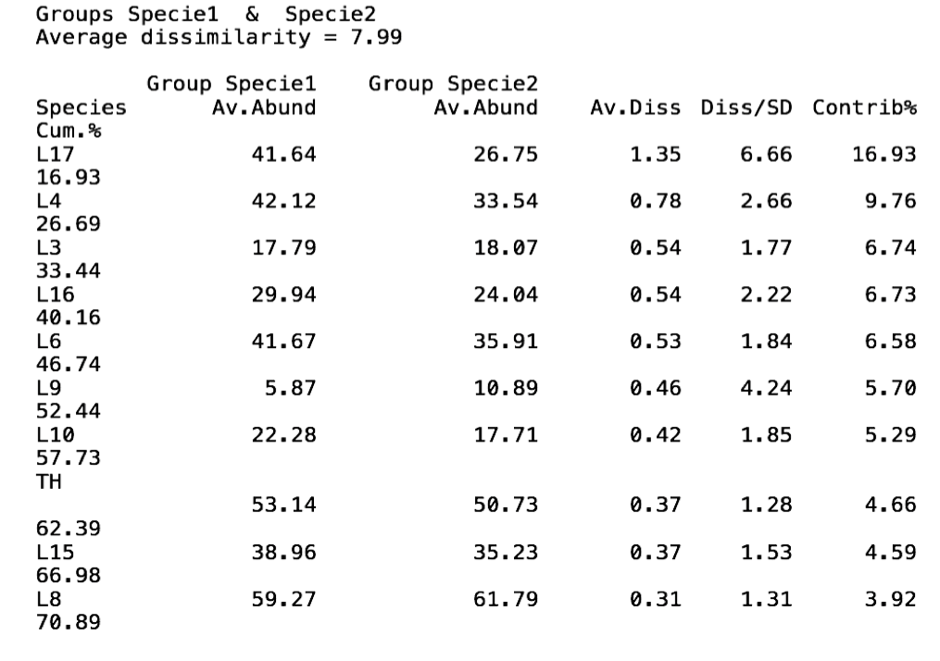
Table S3. Details on the specimens analysed in this paper with labrum anormalities
Specimen code | deformation type | N ambulacral plates in contact on each side | other deformation
035-18-9 | deformed labrum
059-18-3 |  | 2 plates
059-18-17 |  | 2 plates
060-18-6 |  |  | 1 genital pore closed
060-18-8 | deformed labrum
060-18-13 | deformed labrum
061-18-2 |  | 2 plates
061-18-5 |  | 2 plates
061-18-10 |  |  | 1 genital pore closed
062-18-8 | dubled labrum
063-18-4 | deformed labrum
063-18-7 | absent labrum
063-18-9 |  | 2 plates
067-18-3 | deformed labrum | 2 plates
067-18-6 | very long labrum
067-18-8 |  | 2 plates.
067-18-9 |  | 2 plates
067-18-10 |  |  | 1 genital pore closed
067-18-11 | deformed labrum (very short)
067-18-14 | deformed labrum
067-18-17 | deformed labrum
067-18-22 | deformed labrum
067-18-28 | deformed labrum | 2 plates
067-18-29 | deformed labrum
067-18-31 | deformed labrum
067-18-33 | short labrum
067-18-34 | deformed labrum, very long and pointed to rear
090-18-3 | deformed labrum
091-18-3 |  |  | deformed periproct
091-18-8 |  |  | deformed periproct
091-18-12 |  | 2 plates
091-18-13 | long labrum
097-18-3 | narrow and long labrum
MACIVM-18-20 |  | 2 plates
Total 34 of 260 =13% | 20 of 266 = 7,69% | 11 of 266 = 4,23% | 5 of 260 = 1,92%Supplementary Figures and Tables

Table S4. Details on the specimens genetically analysed in this paper
Specimen Code | COI GenBank N | 16S GenBank N | Morphotype
Sp01_026-MED-18 | OP361060 | OP359422 | A
Sp02_026-MED-18 | OP361061 | - | A
Sp01_029-MED-18 | OP361062 | OP359423 | A
Sp01_030-MED-18 | OP361063 | OP359424 | A
Sp02_030-MED-18 | OP361064 | OP359425 | A
Sp01_090-MED-18 | OP361065 | OP359426 | A
Sp01_062-MED-19 | - | OP359427 | A
Sp02_062-MED-19 | OP361066 | OP359428 | A
Sp04_064-MED-19 | OP361067 | OP359429 | A
Sp02_074-MED-19 | OP361068 | OP359430 | A
SX1_074-MED-18 | OP361069 | OP359431 | B
SX2_074-MED-18 | OP361070 | OP359432 | B
SX3_074-MED-18 | OP361071 | OP359433 | B
SX1_081-MED-19 | OP361072 | OP359434 | B
SX2_081-MED-19 | OP361073 | OP359435 | B

Table S5. Sequences from the GenBank and BOLD databases used in this study. na = not available. * = BOLD Record Number (Ratnasingham and Hebert, 2007)
GenBank Accession N |  | Species | Location | Reference
16S | COI
AJ639822 | na | Brissus unicolor | na | Stockley et al., unpublished
na | MN683889-91 | Brissus unicolor | Honduras, Caribbean Sea, Atlantic | Collin et al., 2020
AJ639813 | AJ639913 | Echinocardium laevigaster | na | Stockley et al., 2005
AJ639810 | AJ639910 | Spatangus multispinus | New Zealand, SW Pacific | Stockley et al., 2005
AJ639811 | AJ639911 | Spatangus raschi | UK, North Sea, NE Atlantic | Stockley et al., 2005
AY652517 | na | Spatangus purpureus | North Sea, NE Atlantic | Kirby and Lindley, 2005
KR270989 | na | Spatangus purpureus | NE Atlantic/Mediterranean | Egea et al., 2016
KR270990 | na | Spatangus purpureus | NE Atlantic/Mediterranean | Egea et al., 2016
KR270991 | na | Spatangus purpureus | NE Atlantic/Mediterranean | Egea et al., 2016
KR270992 | na | Spatangus purpureus | NE Atlantic/Mediterranean | Egea et al., 2016
KR270993 | na | Spatangus purpureus | NE Atlantic/Mediterranean | Egea et al., 2016
EF999843 | na | Spatangus purpureus | na | Chenuil et al., 2008
na | KX459102 | Spatangus purpureus | Norway, North Sea, NE Atlantic | Laakmann et al., 2016
na | KX459103 | Spatangus purpureus | Norway, North Sea, NE Atlantic | Laakmann et al., 2016
na | KX459104 | Spatangus purpureus | Norway, North Sea, NE Atlantic | Laakmann et al., 2016
na | KX459105 | Spatangus purpureus | Norway, North Sea, NE Atlantic | Laakmann et al., 2016
na | KX459106 | Spatangus purpureus | UK, North Sea, NE Atlantic | Laakmann et al., 2016
na | KX459107 | Spatangus purpureus | UK, North Sea, NE Atlantic | Laakmann et al., 2016
na | KX459108 | Spatangus purpureus | UK, North Sea, NE Atlantic | Laakmann et al., 2016
na | HM889127 | Spatangus mathesoni | New Zealand, SW Pacific | Anderson & Steinke, unpublished
na | HM889128 | Spatangus multispinus | New Zealand, SW Pacific | Anderson & Steinke, unpublished
na | HQ967249 | Spatangus multispinus | New Zealand, SW Pacific | Anderson & Steinke, unpublished
na | HQ967250 | Spatangus multispinus | New Zealand, SW Pacific | Anderson & Steinke, unpublished
na | NZECA720-11* | Spatangus sp. | New Zealand, SW Pacific | Anderson & Steinke, unpublished
na | MN683889 | Brissus unicolor | Honduras, W Atlantic | Collin et al, 2020
na | MN683890 | Brissus unicolor | Panama, E Pacific | Collin et al, 2020
na | MN683891 | Brissus unicolor | Honduras, W Atlantic | Collin et al, 2020
na | DISA374-18* | Spatangus californicus | California, NW Pacific | ---

2.2 Supplementary Figures
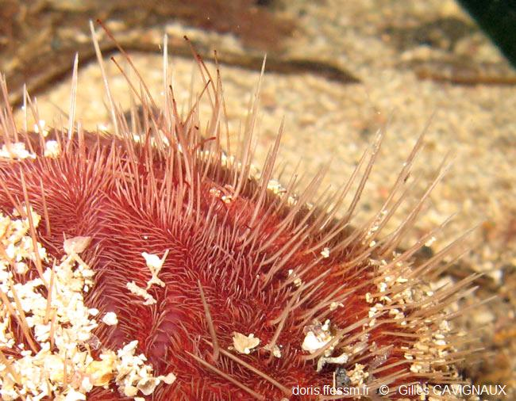
Supplementary Figure S1. Spatangus purpureus Müller 1776, semi-sunken individual. Provence-Alpes-Côte d'Azur, France. Photo Frédéric ANDRÉ, by kind permission, in DORIS, Données d'Observations pour la Reconnaissance et l'Identification de la faune et la flore Subaquatiques.

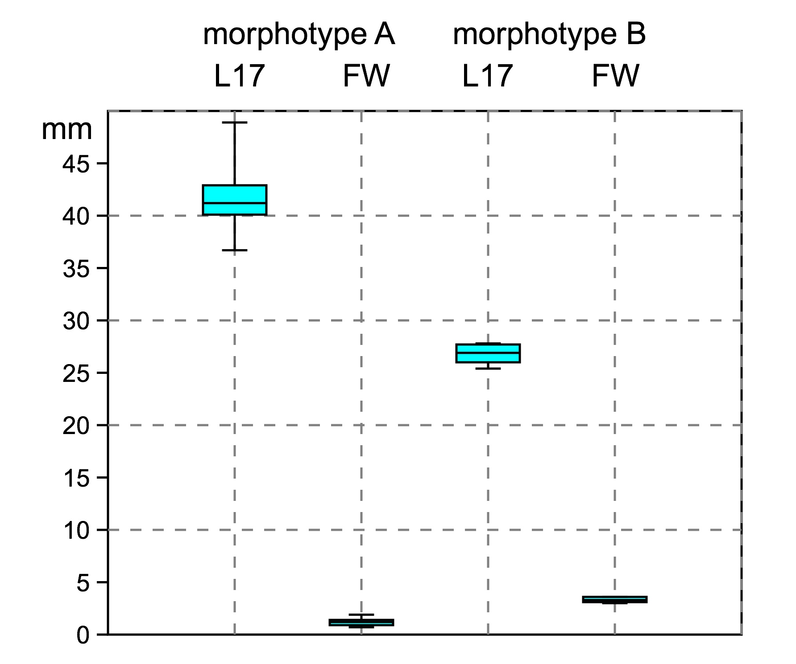
Supplementary Figure S2. Box plot of fasciole variability and differences between Morphotype A (Spatangus purpureus) and B (Propespatangus sp.1).

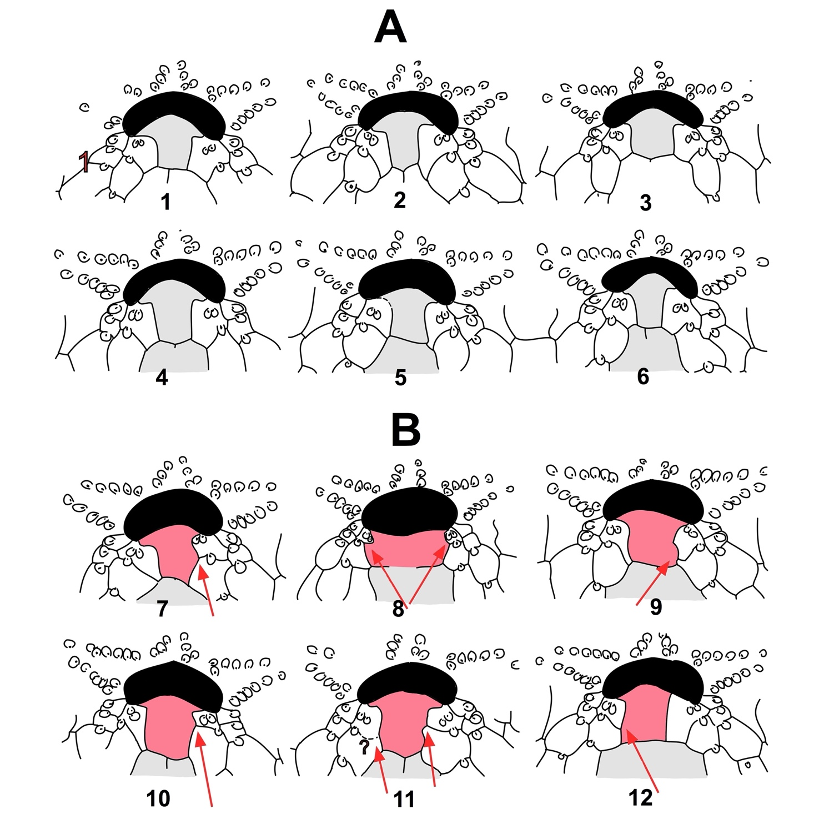
Supplementary Figure S3. Spatangus purpureus. A - Figures 1-6 - representative schemes of the labrum shape variability and relationship with adjacent ambulacral plates (specimens 063-MED-18-2; 067-MED-18-13, 35, 6, 17, in order. B - Anomalous contact with the adjacent ambulacral plates (specimens 067-MED-18- 4, 28, 3; 59-18-17; 67-18-29; NL-MED-18-20, respectively; arrows indicate abnormal contact points.
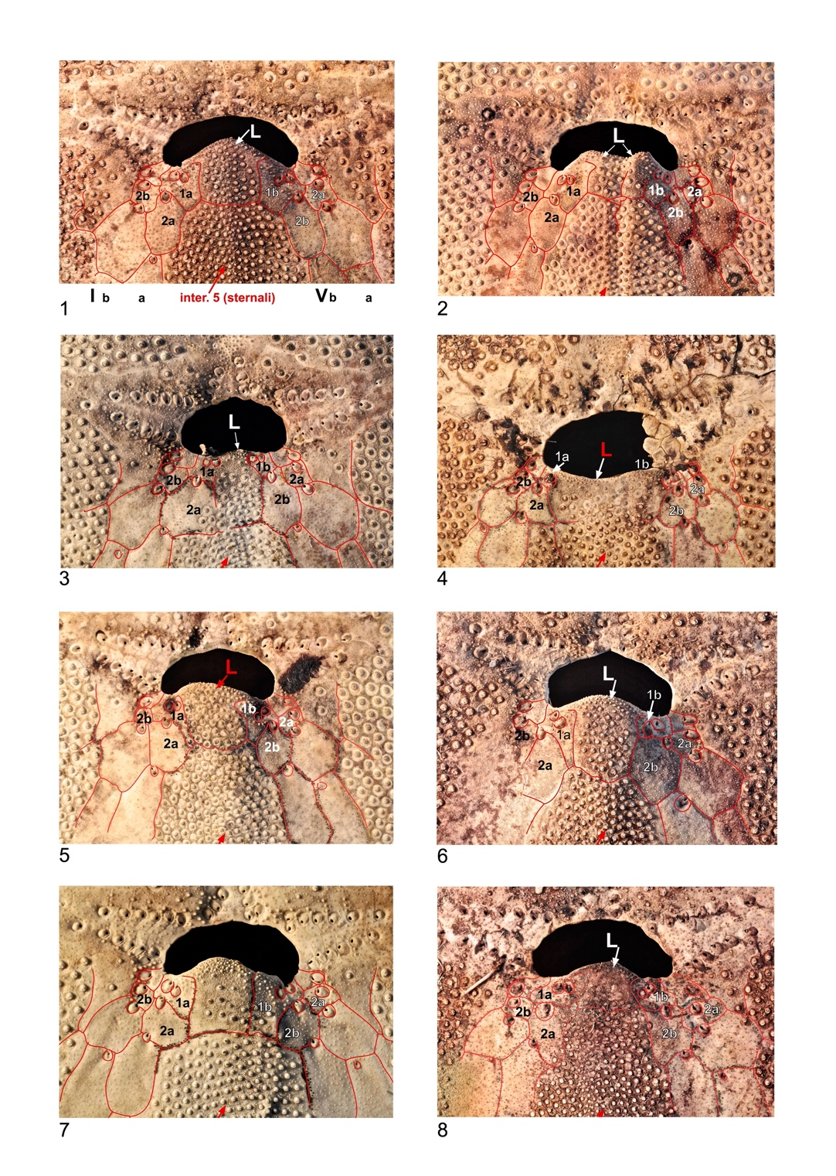
Supplementary Figure S4. Spatangus purpureus. 1 - specimen 067-MED-18-35. normal labrum: an adjacent ambulacral plate in contact on each side. 2 - specimen 062-MED-18-8: split labrum, normal adjacent contacts. 3 - specimen 63-MED-18-8: deformed labrum, 2 adjacent ambulacral plates in contact on each side. 4 - specimen 67-MED-18-28: rudimentary labrum with 2 adjacent ambulacral plates in contact on each side. 5 - specimen 67-MED-18-3: labrum deformed, but in contact with an adjacent ambulacral plate on each side. 6 - specimen 59-MED-18-17, in normal contact in column Ia and abnormal (with two plates) in column Vb. 7 - specimen NL-MED-18-20: in normal contact with the adjacent plate in column Vb and abnormal (with two plates) in column Ia. 8 - specimen 67-MED-18-31: shortened labrum, in normal contact with the adjacent plate in column Vb and abnormal (with two plates) in the column Ia. Sutures highlighted in red.
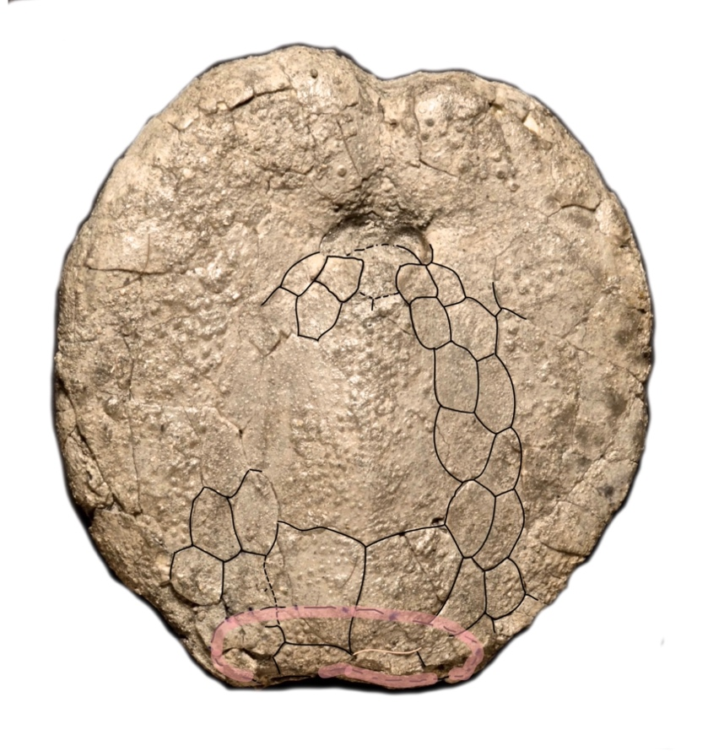
Supplementary Figure S5. Adoral scheme of Spatangus sp.2 from Miocene of Ukraine.

Supplementary Figure S6. Oral view of Spatangus cf. purpureus from Pliocene (Gelasian) of San Nicomede, Salsomaggiore (Parma) Emilia-Romagna, Italy TL=100 mm. Courtesy E. Borghi.

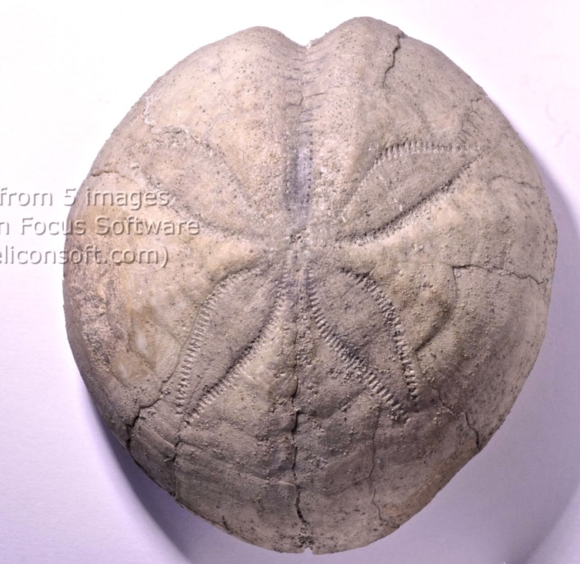
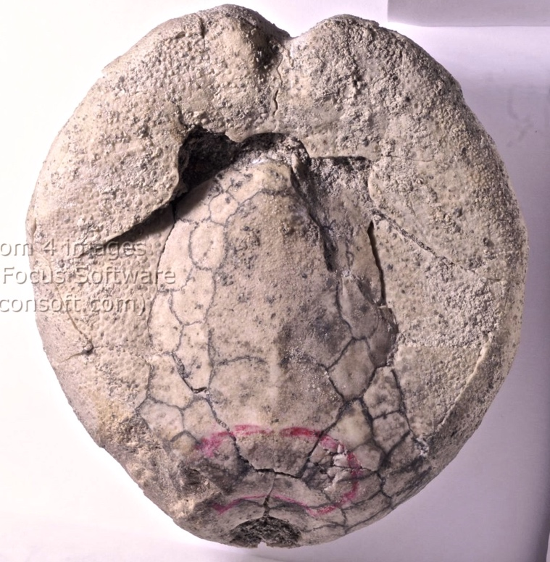
a b
Supplementary Figure S7. Aboral and oral view of Spatangidae indetermined from Mio-Pliocene of Florida (USA).

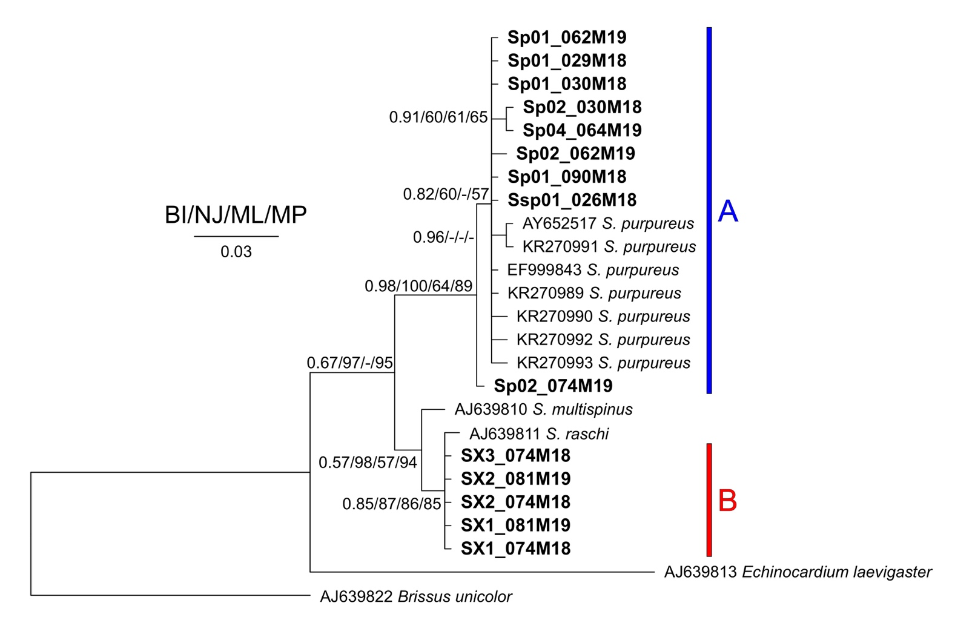
Supplementary Figure S8. Tree obtained with the 16S sequences. Near the nodes are the values for the Bayesian probabilities (BI) or the bootstrap support (NJ/ML/MP). In bold the Sardinian spatangids.

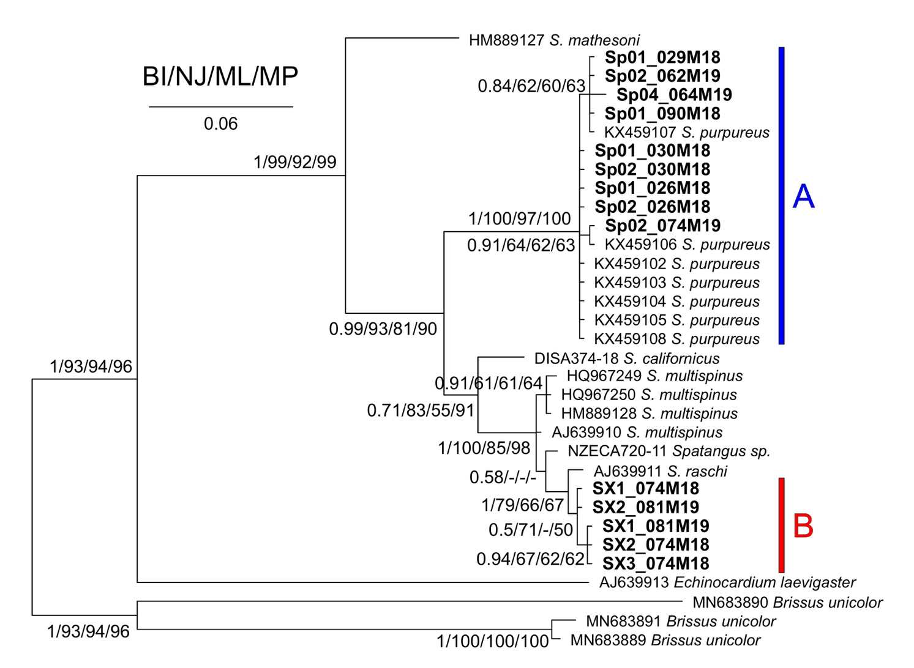
Supplementary Figure S9. Tree obtained with the COI sequences. Near the nodes are the values for the Bayesian probabilities (BI) or the bootstrap support (NJ/ML/MP). In bold the Sardinian spatangids.
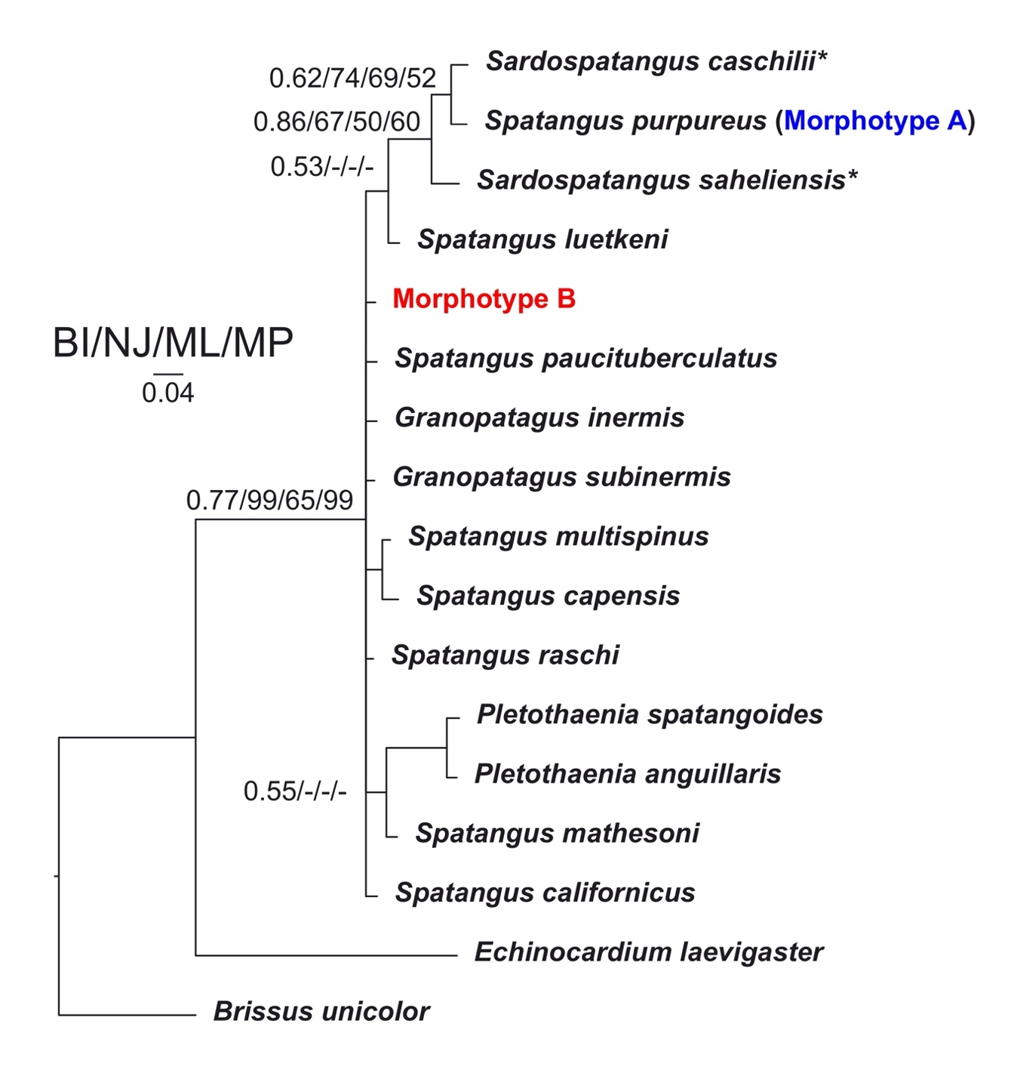
Supplementary Figure S10. Tree of morphological characters listed in Table S6 Near the nodes are the values for the Bayesian probabilities (BI) or the bootstrap support (NJ/ML/MP). The asterisks indicate fossil taxa.

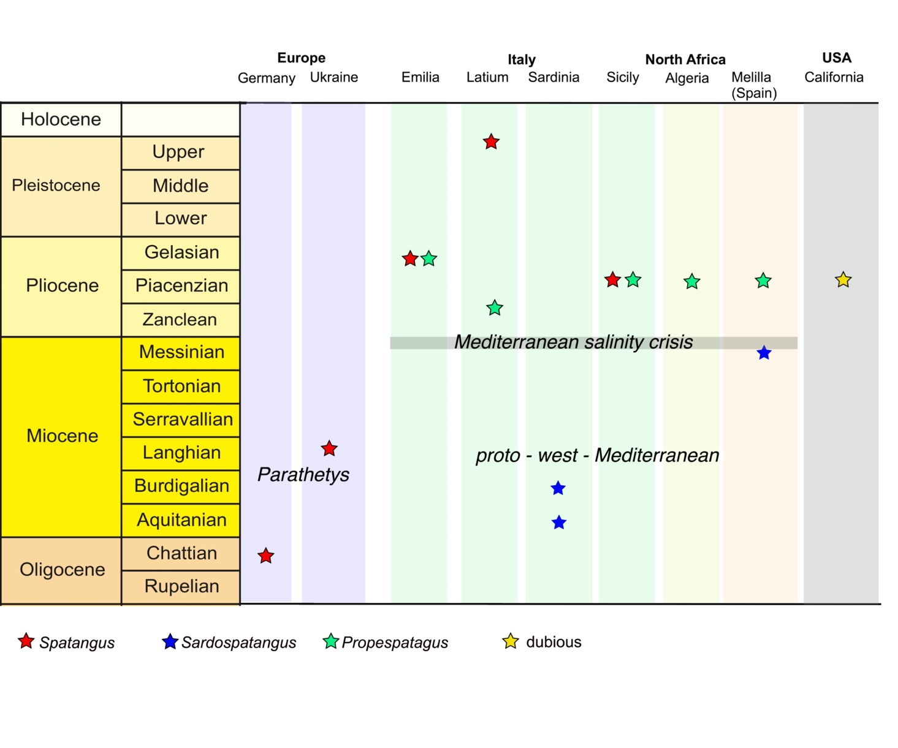
Supplementary Figure S11. Stratigraphic relationship between species analyzed.

References
Chenuil, A., Egea, E., Rocher, C., Touzet, H., and Feral, J.P. (2008). Does hybridization increase evolutionary rate? Data from the 28S-rDNA D8 domain in echinoderms. J Mol Evol 67(5), 539-550. doi: 10.1007/s00239-008-9171-8.
Collin, R., Venera-Pontón, D.E., Driskell, A.C., Macdonald, K.S., Geyer, L.B., Lessios, H.A., et al. (2020). DNA barcoding of echinopluteus larvae uncovers cryptic diversity in neotropical echinoids. Invertebrate Biology 139(2), e12292. doi: https://doi.org/10.1111/ivb.12292.
Egea, E., David, B., Chone, T., Laurin, B., Feral, J.P., and Chenuil, A. (2016). Morphological and genetic analyses reveal a cryptic species complex in the echinoid Echinocardium cordatum and rule out a stabilizing selection explanation. Mol Phylogenet Evol 94(Pt A), 207-220. doi: 10.1016/j.ympev.2015.07.023.
Kirby, R.R., and Lindley, J.A. (2005). Molecular analysis of Continuous Plankton Recorder samples, an examination of echinoderm larvae in the North Sea. Journal of the Marine Biological Association of the United Kingdom 85(3), 451-459. doi: 10.1017/S0025315405011392.
Laakmann, S., Boos, K., Knebelsberger, T., Raupach, M.J., and Neumann, H. (2016). Species identification of echinoderms from the North Sea by combining morphology and molecular data. Helgoland Marine Research 70(1). doi: 10.1186/s10152-016-0468-5.
Ratnasingham, S., and Hebert, P.D. (2007). BOLD: The Barcode of Life Data System (http://www.barcodinglife.org). Mol Ecol Notes 7(3), 355-364. doi: 10.1111/j.1471-8286.2007.01678.x.
Stockley, B., Smith, A.B., Littlewood, T., Lessios, H.A., and Mackenzie-Dodds, J.A. (2005). Phylogenetic relationships of spatangoid sea urchins (Echinoidea): taxon sampling density and congruence between morphological and molecular estimates. Zoologica Scripta 34(5), 447-468. doi: 10.1111/j.1463-6409.2005.00201.x.

